

Romanized Sinhala to Sinhala Reverse Transliteration using a Hybrid Approach

A Thesis Submitted for the Degree of Master of Computer Science


T.G.D.K. Sumanathilaka University of Colombo School of Computing 2022
DECLARATION

I hereby declare that the thesis is my original work, and it has been written by me in its entirety.

I have duly acknowledged all the sources of information which have been used in the thesis.

This thesis has also not been submitted for any degree in any university previously.

Student Name: TGDK Sumanathilaka

Registration Number: 2019/MCS/084
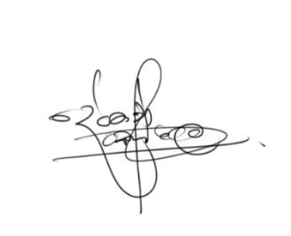

Index Number:19440847

__________________________ 20/11/2022

Signature of the Student & Date

This is to certify that this thesis is based on the work of Mr T.G.D.K. Sumanathilaka under my supervision. The thesis has been prepared according to the format stipulated and is of an acceptable standard.

Certified by,


Supervisor Name: Dr Ruvan Weerasinghe

23/02/2023
_____________________________________

Signature of the Supervisor & Date

i

ගිනි කාෂ්ටකඅව්වව් දහදිය වහලමින් උපයා ගත් ව ාච්චවෙන් ො මිනිව කු කල ොවේ පියානන් ටත්, වේ කිරි කර වපාවා ආදරය, කරුණාව කියා දුන් ෙවේ ෙෑණියන් ටත්, ො උගවෙකු කරන්නට ොවේ අධ්‍යාපනයට බදු වගවූ ශ්‍රී ලාාංකිකයන්ටත් ඉෙහත් ආදරවයන්…

I would like to dedicate this thesis to the people in Sri Lanka!

ii

ACKNOWLEDGEMENTS

It was a challenging adventure to conclude this research project in a year, but it was also a tremendous learning experience. Without the generous assistance, direction, and inspiration of numerous people who stood by my side, I would not have been able to finish my research. I want to say thank you to each one of you.

I would first like to thank my supervisor, Dr Ruvan Weerasinghe, for his guidance, and support and for pushing me to do my best Masters Thesis, from the idea initiation to the final submission. Also, my sincere gratitude goes to Mr Prasan Yapa, the External supervisor of the project, for his support and guidance throughout the project without any hesitation. Furthermore, I would like to thank all the lecturers at the University of Colombo, School of Computing for their endless knowledge and guidance throughout the master’s degree period.

Next, I would like to express my sincere thanks to all evaluators, domain, and technical experts, of this research for providing their expertise and knowledge throughout the research. Further, I would like to extend my gratitude to my friends and company - Informatics Institute of Technology (IIT) colleagues for their valuable feedback and support during the project.

Finally, I would like to express my loving gratitude to my family, who has been my pillars of success throughout my life.

iii

ABSTRACT

With the revolution of social technology, the introduction of social media platforms and instant messages strengthen the native language used for communication in electronic media. With the commencement of multi-language compatibility in the digital arena both native Sinhala and Romanized Sinhala became prominent among the general community. Machine transliteration provides the ability to transliterate the alphabet of one language to another using computational approaches. The informal shorthand language that uses in texting also known as “Singlish” makes texting easier as the words in Sinhala can be interpreted using English letters with different typing patterns. But typing “Romanized Sinhala” using ad hoc transliterations and short net acronyms and getting the expected output in native Sinhala is less accurate.

The current transliterators with a rule-based approach use a letter-level transliteration with a defined rule for the transliteration schema. But Romanized Sinhala via shortened hand-based typing is not compatible with the current system. The proposed ad-hoc schema uses multiple computational approaches Aka Hybrid Approach to accomplish the requirement of ambiguity-free transliteration. The statistical approach used in the first phase uses an N-gram tagger where the tokens are fed to Trigram, Bigram, and Unigram taggers respectively. The unknown token from the initial phase is fed to the second phase with a Rule-based Algorithm which will predict respective words. The third phase which is the finalizing phase uses a suggestion-level model implemented using a Trie and Knowledge base to find the most optimal word suggestions from the predicted words pool. This phase will solve the ambiguity of a word selection.

The Transliterator has been tested with the testing data and word level accuracy achieved was 84%. Therefore, the proposed novel transliterator which can back transliterate Romanized Sinhala to Sinhala using the Hybrid approach can use to enhance the reverse transliteration schema which will escalate the usage of Native Sinhala for communication.

Keywords: Romanized Sinhala, Transliteration, Neural Approach, Statistical approach, Sinhala, Typing

iv

LIST OF PUBLICATIONS

  - Full Paper: Swa-Bhasha Romanized Sinhala to Sinhala Reverse Transliteration using a Hybrid Approach
o Conference: 03rd International Conference on Advanced Research in Computing(ICARC 2023)

o Venue: University of Sabaragamuwa, Belihul oya, Sri Lanka

o Date: 23rd February 2023

  - Extended Abstract Paper: Romanized Sinhala to Sinhala Transliteration using a Hybrid Approach
o Conference: International Conference on Innovations in Info-business & Technology (ICIIT2022)
o Venue: Colombo, Sri Lanka

o Date: 18th February 2022

  - Abstract Paper: Ad-hoc Transliteration Schema for Romanized Sinhala to Sinhala
o Conference: 5th Student-STAFF Research Conference (SSRC22)

o Venue: London, UK (Virtual)

o Date: 2nd of March 2022

- Abstract Paper: A Rule-based Approach to Generate low-resourced Sinhala to Romanized Sinhala Ad-hoc transliterals based on Survey Data

o Conference: International conference of Innovation and Emerging Technologies 2022 (ICIET 2022)

- Venue: University of Sri Jayewardenepura, Homagama, Sri Lanka

- Date: 25th and 26th of November 2022

v

- Abstract Paper: Sinhala word suggestion algorithm for ad hoc Romanized Sinhala transliterations using a Trie

  - Conference: 10th Ruhuna International Science and Technology Conference

  - Venue: University of Ruhuna, Matara, Sri Lanka

  - Date: 18th of January 2023

- Awards Prizes: Best Extended Abstract Paper Award

  - Conference: International Conference on Innovations in Info-business & Technology (ICIIT2022)
  - Title: Romanized Sinhala to Sinhala Transliteration using a Hybrid Approach

  - Venue: Colombo, Sri Lanka

  - Date: 18th February 2022

- Awards Prizes: Best Abstract Paper Award (Postgraduate)

  - Conference: International conference of Innovation and Emerging Technologies 2022 (ICIET 2022)

  - Title : Sinhala word suggestion algorithm for ad hoc Romanized Sinhala transliterations using a Trie
  - Venue: University of Sri Jayewardenepura, Homagama, Sri Lanka

  - Date: 25th and 26th of November 2022

vi
TABLE OF CONTENTS

Contents

CHAPTER 1 ........................................................................................................................ |  |  | 1
INTRODUCTION ............................................................................................................... |  |  | 1
1.1 | Chapter Overview........................................................................................................... |  | 1
1.2 Problem Domain / Background ..................................................................................... |  |  | 1
1.2.1 |  | Language Transliteration ....................................................................................... | 1
1.2.2 |  | Romanized Sinhala .................................................................................................. | 2
1.2.3 |  | Sinhala Language .................................................................................................... | 2
1.2.3 |  | Natural Language Processing ................................................................................. | 3
1.3 | Problem Definition ......................................................................................................... |  | 3
1.4 Problem Statement ......................................................................................................... |  |  | 4
1.5 | Research Motivation....................................................................................................... |  | 4
1.6 | Existing Work ................................................................................................................. |  | 5
1.7 Research Gap .................................................................................................................. |  |  | 6
1.8 | Contribution to the body of knowledge ........................................................................ |  | 7
1.9 | Research Challenge ........................................................................................................ |  | 7
1.10 Research Questions....................................................................................................... |  |  | 8
1.11 Research Aim ................................................................................................................ |  |  | 8
1.12 Research Objectives ..................................................................................................... |  |  | 8
1.13 Project Scope ................................................................................................................. |  |  | 9
1.13.1 In scope ................................................................................................................... |  |  | 9
1.13.2 Out scope .............................................................................................................. |  |  | 10
1.14 Prototype Feature Diagram ....................................................................................... |  |  | 10
1.15 Chapter Summary and Structure of the dissertation.............................................. |  |  | 10
CHAPTER 2 ...................................................................................................................... |  |  | 13
LITERATURE REVIEW .................................................................................................. |  |  | 13
2.1 | Chapter Overview......................................................................................................... |  | 13
2.2 Problem Domain ........................................................................................................... |  |  | 13
2.2.1 |  | Introduction to Natural Language Processing .................................................... | 13
2.2.2 |  | Machine Translation ............................................................................................. | 14
2.2.3 |  | Computational Linguistics .................................................................................... | 15
2.2.4 |  | Sinhala Language .................................................................................................. | 16
 |  | vii

2.3 Existing Work ............................................................................................................. |  | 19
2.3.1 | Technology and Algorithms Review .................................................................... | 19
2.3.2 | Comparison of the Algorithms ............................................................................. | 23
2.3.3 | Tools and Techniques ............................................................................................ | 25

2.4 Chapter Summary ........................................................................................................ |  | 26
CHAPTER 3 ...................................................................................................................... |  | 27
METHODOLOGY ............................................................................................................ |  | 27
3.1 | Chapter Overview......................................................................................................... | 27
3.2 | Research Methodology ................................................................................................. | 27
3.3 | Development Methodology .......................................................................................... | 28
3.4 Project Management Methodology ............................................................................. |  | 28
3.5 | Data Collection Methodology ...................................................................................... | 29
3.5.1 Data set Selection ................................................................................................... |  | 29
3.5.2 Data set Annotation ............................................................................................... |  | 29
3.6 | Requirement Elicitation ............................................................................................... | 31
3.6.1 Discussion on findings from Requirement Elicitation techniques. ................... |  | 33
3.7 | System Architecture and Design Overview ................................................................ | 38
3.8 | Process Flow Chart ....................................................................................................... | 41
3.9 | Algorithms ..................................................................................................................... | 42
3.9.1 The Statistical approach with N-gram tagger. .................................................... |  | 42
3.9.2 The Rule base Approach ....................................................................................... |  | 42
3.9.3 The Knowledge-based approach .......................................................................... |  | 42
3.10 UI Design ..................................................................................................................... |  | 43
3.11 Chapter Overview....................................................................................................... |  | 43
CHAPTER 4 ...................................................................................................................... |  | 44
IMPLEMENTATION ....................................................................................................... |  | 44
4.1 | Chapter Overview......................................................................................................... | 44
4.2 | Technology Stack .......................................................................................................... | 44
4.3 | Data Annotation algorithm .......................................................................................... | 45
1.4 Ngram Model for Romanized Sinhala to Sinhala ...................................................... |  | 46
1.5 Rule-based Approach ................................................................................................... |  | 47
1.6 Trie model Training and Best Word Suggestion ....................................................... |  | 48
1.6.1 Trie Model training ............................................................................................... |  | 48
1.6.2 Best Word Suggestion ............................................................................................ |  | 48
1.7 GUI Implementation .................................................................................................... |  | 49
 | viii

1.8 GUI ................................................................................................................................. |  |  | 51
1.9 Chapter Summary ........................................................................................................ |  |  | 51
CHAPTER 5 ...................................................................................................................... |  |  | 52
EVALUATION AND RESULTS ..................................................................................... |  |  | 52
5.1 | Chapter Overview......................................................................................................... |  | 52
5.2 | Evaluation Methodology and Approach..................................................................... |  | 52
5.3 | Evaluation Criteria ....................................................................................................... |  | 53
5.3.1 |  | Self-evaluation ........................................................................................................ | 53
5.3.2 |  | Qualitative Evaluation .......................................................................................... | 53
5.3.3 |  | Quantitative Evaluation ........................................................................................ | 57
5.3.4 |  | Numerical Analysis ................................................................................................ | 59
5.3.5 |  | Evaluation of Functional Requirements. ............................................................. | 60
5.3.6 |  | Evaluation of the Research Questions ................................................................. | 61
5.4 | Benchmarking the functionalities ............................................................................... |  | 62
5.5 Chapter Summary ........................................................................................................ |  |  | 62
CHAPTER 6 ...................................................................................................................... |  |  | 63
CONCLUSION AND FUTURE WORKS ........................................................................ |  |  | 63
6.1 | Chapter overview .......................................................................................................... |  | 63
6.2 | Conclusion ..................................................................................................................... |  | 63
6.3 | Limitations of the Research ......................................................................................... |  | 63
6.4 | Future work of the Research ....................................................................................... |  | 64
6.4.1 |  | Research Components ........................................................................................... | 64
6.4.2 |  | Product Component .............................................................................................. | 64
6.5 Chapter Summary ........................................................................................................ |  |  | 64
REFERENCES .................................................................................................................... |  |  | I
Appendix |  | ........................................................................................................................... | III

ix
LIST OF FIGURES

Figure 1.1 Sinhala Alphabet 3

Figure 1.2 Prototype Feature Diagram of Transliterator (Self Composed) 10

Figure 2.1 Translation overview 26

Figure 2.2 Machine Translation 16

Figure 2.3 Phonetic Chart for Sinhala Alpahabet 17

Figure 2.4 Sinhala transliteration Chart 18

Figure 2.5 Rule Based Architecture 20

Figure 2.6 High level encoder decoder Architecture 23

Figure 3.1 Adhoc Transliterals generation 43

Figure 3.2 3-tired Architecture 39

Figure 3.3 Process Flow Diagram 41

Figure 3.4 UI Design 43

Figure 4.1 Trie Model training 48

Figure 4.2 GUI for suggestion level Transliterator 51

Figure 4.3 GUI for Transliterator home page 51

x
LIST OF TABLES

Table 2.1 Most Common typing patterns in Romanized Sinhala 18

Table 2.2 Algorithm Comparison 23

Table 3.1 Sinhala sentences used to identify the patterns in the survey 30

Table 3.2 Results of data annotation algorithm 31

Table 5.1 Evaluation Criteria for Quantitative data in Survey 57

xi
LIST OF ABBREVIATIONS

Abbreviation | Description
FR | Functional Requirement
LSTM | Long Short-Term Memory
NFR | Non Functional Requirement
NLP | Natural Language Processing
NLTK | Natural Language Tool Kit
MT | Machine Translation
POS | Part of Speech
SVM | Support Vector Machine

xii
CHAPTER 1

INTRODUCTION

1.1 Chapter Overview

This chapter establishes an overview of the research project undertaken. The background of the research, scope, requirements, and objectives are detailed in this chapter. In nutshell, this chapter defines the problem, limitations of the currently existing systems, and other contributing factors that inspired and influenced the pursuit of the research.

1.2 Problem Domain / Background

1.2.1 Language Transliteration

According to the Oxford Dictionary, the word transliteration can be defined as “the act of writing words or letters using letters of a different alphabet or language. The word transliteration comes from the Latin word “transliteratus” which explains “trans” as across and “Littera” as a letter. Transliteration helps people to pronounce words and names in foreign languages. As an example, the Sinhala word “අම්ො” is represented using English as “Amma”. Unlike translation, which tells the user about the meaning of a particular word, transliteration only provides an idea of how the word is pronounced by using a familiar language.

- Reverse Transliteration

The reverse transliteration explains, “A word or a sentence of a particular language expressed using different languages will be converted to the original language Schema. As an example, the Sinhala word “වකාවහාෙද” which is expressed as Roman English “kohomdha” can be re-transliterated to the original word “වකාවහාෙද” using the Reverse transliteration techniques.

This study is mainly focused on reverse transliteration where Romanized Sinhala will be translated into Sinhala characters.

- Transliteration vs. Translation

The transliteration process means that a word expressed in a character set like the Sinhala alphabet is transposed in another language model, say the English alphabets. In other words, there is no translation involved. If the source word means nothing in the given language,

1
its transliterated form will also mean nothing, even though it will look like a word in that language as it will be written in its alphabet or syllabic system.

1.2.2 Romanized Sinhala

Writing letters and words belonging to Sinhala Language using the English alphabet is known as Romanized Sinhala. As an example, the Sinhala word “අම්ො” can be written as "Amma" using Romanized Sinhala Characters. This symbolic pattern was introduced to write pali in 2009 and later it was adapted to the Sinhala Language.

1.2.3 Sinhala Language

Sri Lanka is a South Asian country with 21,436,802 population (Division, 2020). Approximately 16 million people of the total population speak ‘Sinhala’ as one of their national languages. Many changes in the Sinhala Language can be identified in different communities where minor changes in pronunciation can be seen. This language is only spoken by Sri Lankans in the world. The Sinhala language is related to the Indo-Aryan language family which is a branch of the Indo-European languages (Gallege, 2010).

In the Sinhala alphabet, there are 60 basic characters with 18 vowel letters and 42 constant letters. 18 vowel letters have included 2 fricatives, 8 stops, 2 affricatives, 2 nasals, 2 glides and 2 liquids an (Gallege, 2010). This language has many grammatical rules for correct interpretation of the language were identifying the morph of a word is complex compared to the other languages. Many systems have been implemented to translate other languages into Sinhala and vice versa. With the huge growth of social media and Sinhala language-based blogging, the usage of Sinhala for the day today usage has become prominent. NLP (Natural Language Processing) technology was used for the translation process. Most often, MT (Machine Translation), a subset of NLP, is used for language translation with different algorithms and different approaches. In Machine learning multiple computational linguistics which can define as Rule-based (RB), Statistical, Example-based (EB), Human- assisted, Knowledge-based, Hybrid, Dictionary, and Agent-based (R. M. M. Shalini1, 2017) are used to build accurate models related to Sinhala Computational Domain.

2
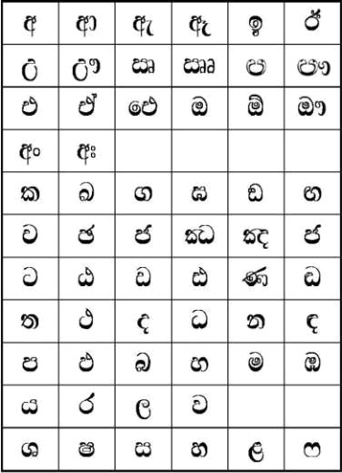

Figure 1.1 Sinhala Alphabet

1.2.3 Natural Language Processing

Natural Language Processing, simply called NLP, can be categorized under Artificial Intelligence. The main task and goal of NLP are to make machines understand language the way humans understand language. (Garbade, 2018). Using this understanding of the language patterns, symbolic representation and Grammatical structure, NLP-based models feed the computer knowledge of the language model which could understand the Syntax and semantics related to a word or a sentence. This helps to bridge the language barrier between machines and human beings.

Below are some of the most famous applications which use NLP.

- Email filters.

- Smart assistants.

- Text Classification.

- Text Translation and Transliteration.

- Topic Modelling.

- Language Identification.

- Grammar checkers.

- Search results, etc.

These techniques are used with text based computation in Natural Language Processing. In this research, the author will focus on the Transliteration of Romanized Sinhala to Sinhala.

1.3 Problem Definition

With the revolution of technology, the introduction of social media platforms with instant message and commenting applications strengthens the usage of native languages for

3
communication on electronic media. With the commencement of muti-language compatibility in digital platforms, Sri Lankans tend to use both Native Sinhala and Romanized Sinhala for their day today typing purposes. But Typing “Romanized Sinhala” using ad hoc transliteration or short net acronyms and getting the expected output in native Sinhala is a less accurate and time-consuming process with existing transliteration keyboards. As an example, with the available Transliteration keyboards, the word “වකාවහාෙද” can be generated only using the Romanized Sinhala word “Kohomadha”, where it follows a defined rule for the transliteration. But the proposed idea aims to transliterate short typing patterns like “khmda ,kohomda, kohomada, khmada ,khmd” to the native Sinhala word “වකාවහාෙද”. Therefore, introducing a novel reverse-transliterator that back transliterates ‘Romanized Sinhala” intelligently would make typing and messaging much more convenient. This study is mainly focused on enhancing the reverse transliteration schema which will escalate the usage of the Native Sinhala for communication.

1.4 Problem Statement

Typing Romanized Sinhala using ad hoc transliterations with vowels, without vowels or including both ways and getting the expected output in native Sinhala is a less accurate and complex process with the existing Sinhala-English keyboard. But introducing a real-time reverse transliterator that transliterates Romanized Sinhala to Sinhala based on message-based typing can effectively enhance the typing experience of Sinhala users.

1.5 Research Motivation

With the usage of English to Sinhala keyboard, typing a Sinhala word using Romanized Sinhala is complicated. The pre-defined typing structure must be followed in the process where word transliteration is following a unique rule in the transliteration process. As an example, if you want to type වකාවහාෙද on available keyboards, you are supposed to follow the defined pattern of “kohomadha”. But the same word can be present in the manner of “khmda, kohomda, khmd, kohmda” where available systems don’t transliterate the expected output. According to the Helakuru documentation, it has clearly stated that each Sinhala letter is transliterated using a defined pattern of Romanized Sinhala. But it has been observed many users who use Sinhala to communicate tents to use Romanized Sinhala in different patterns for day-to-day communication. Manly users try to omit the vowels in their typing.

So, this study tries to fill the gap of the complexity of using the pattern in typing Sinhala

4
by adapting the typing schema to with or without vowels where short typing will transliterate the Romanized Sinhala word to the expected Sinhala word accurately.

1.6 Existing Work

The below table discusses the existing work related to translation and transliteration.


 | Research | Brief of the | Limitations | Technologies | Improvements
 | Name and | work
 | Year
1 | (Silva and | Singlish to | Transliteration | Rule-based | Ability to
 | Ahangama, | Sinhala | using N gram | Method with | correct the
 | 2021) | Transliteration | model is less | ensemble | errors in
 |  | model which | accurate and the | learning for | transliterated
 |  | uses ruled | error-correcting | Error | Sinhala words.
 |  | based approach | module | correction
 |  | with an error | depends on the | Module.
 |  | correction | Sinhala corpus.
 |  | module.
2 | (Liwera and | This is Singlish | Less accuracy. | Rule-based | Ability to
 | Ranathunga, | to Sinhala | Focused on | method and | transliterate
 | 2020) | transliteration | Focused on | Trigram | Singlish to
 | 2020) | transliteration | social media. | Trigram | Singlish to
 |  | focused on | social media. | method. | Sinhala.
 |  | social media
 |  | comments.
3 | (Joshi et al., | Using LSTM | Only with 3 | LSTM, | Ability converts
 | 2018) | and sequence 2 | languages | Sequence 2 | Hindi, Sindhi,
 |  | sequence model | Hindi, Sindhi, | Sequence | and Kannada
 |  | to find the | and Kannada | model | words.
 |  | optimal model
 |  | with pre and
 |  | post-processing


5
4 | (Wijerathna | A Rule-based | A limited no of | Rule-Based | Ability to
 | et al., 2012) | machine | rules is used. | approach | translate Sinhala
 |  | translation |  |  | to English and
 |  | system that can |  |  | English Sinhala
 |  | translate |  |  | but with less
 |  | sentences from |  |  | accuracy
 |  | Sinhala to
 |  | English and
 |  | vice versa.
5 | (Antony PJ, | Transliterating | Less accuracy, | SVM, | Ability to
 | 2010) | English to | Support only | Sequence | translate
 |  | Kannada | words. | labelling | English to
 |  | language using |  |  | Kannada.
 |  | SVM.
6 | (Vidanaralage | A Singlish | Character level | Phonetic rule- | A character
 | et al., 2018) | Transliterator | transliteration is | based and | transliteration
 |  | based on a | based on the | Transliteration | that can
 |  | Phonetic chart | suggestion level | rule-based. | transliterate
 |  | and Sinhala | approach. |  | Singlish to
 |  | Transliteration |  |  | Sinhala.
 |  | chart.

1.7 Research Gap

According to research conducted By Liwera (Liwera and Ranathunga, 2020) Singlish to Sinhala Transliteration using trigram and Rule-based approach was tested and evaluated. But the proposed system has 62%word-level accuracy and 77% letter wise accuracy which is mainly trained on social media-based content. The wide variety of Romanized Sinhala patterns has not been used in the system where the ambiguity of the Singlish words is not handled. The research conducted by Vidanaralage (Vidanaralage et al., 2018) attempts to transliterate the Singlish words to Sinhala using a phonetic and Sinhala transliteration chart where the transliteration follows a rule-based approach. Short word typing without vowels and or short net acronyms cannot be transliterated accurately through the system. The research conducted by Wijerathna (Wijerathna et al., 2012) has introduced an approach for converting Sinhala to English where the input to the system is processed using Singlish typing. A rule-based approach for transliteration has been used

6
with the system where entered Singlish will be transliterated to the respective Sinhala word. As a limitation of the system, it will follow a specific pattern in the transliteration process where the different patterns of Singlish typing will generate an error in the transliteration. So, considering the above limitation the researcher of this work attempts to build a robust model which can back transliterate Romanized Sinhala which is written in short letter format to Sinhala. The model will suggest the best possible matching in a case of ambiguity of a word where word-level predicting, and word level suggesting will be tested and evaluated in the work

1.8 Contribution to the body of knowledge

Research contributions will be further divided into domain and software engineering as elaborated below.

Contribution to the Domain

- The author of this work will be building a transliteration dataset using social media comments, and documentation data which will be available for further research.

- Adapting novel schema for Transliteration of Romanized Sinhala to Sinhala using N-gram and Rule base model.

- Enhancing the Rule-based schema in the transliteration process by introducing novel rules to the existing rules.

Contribution to Computer Science

- Sinhala is the language of a low resource where building a novel algorithmic approach for the transliteration process can enhance the usability of Sinhala among the public.

1.9 Research Challenge

The major challenges faced during the study are as follows.

- As Sinhala is a low resource language, finding the best dataset to generate transliteral is challenging.

- Collecting typing patterns from a diverse community.

- Identifying the typing patterns and building a generic approach that suits every person’s typing pattern.

- Building a robust model which performs the task in real-time.

7
1.10 Research Questions

- RQ1: How to create a credible dataset to perform reverse transliteration.

- RQ2: How to identify the Sinhala words and their typing patterns which are frequently used by people when texting.

- RQ3: How to build the most optimal algorithm to reverse-transliterate Romanized Sinhala to Sinhala.

- RQ4: What sort of preprocessing steps and learning methods should be carried out for the main component.

1.11 Research Aim

This research aims to analyze, design, develop and evaluate a generalized system that reverse transliterates Romanized Sinhala to Sinhala using word level N-gram and rule-based module with handling ambiguity in the transliteration process by suggestion algorithm using a Knowledge base.

Further elaboration on the aim, this research project aims to back transliterate the Romanized Sinhala into Sinhala using NLP-based approaches, tools and translating algorithms and to develop an accurate and fast technique to provide native Sinhala words. Therefore

- The Input to the prototype will be Romanized Sinhala where Sinhala will be typed in English.

- The research processes are to find accurate algorithms and NLP-based techniques approach to develop this proposed system with a Romanized Sinhala- Sinhala word dataset.

- The output will be, native (Sinhala) Transliterals and the suggestion level Sinhala transliterals to the user.

1.12 Research Objectives

Objective | Description
The Literature Survey | This study on literature is conducted to have an idea about
 | Natural language processing, machine learning, and
 | technique related to it. Identification of existing systems and
 | their gaps with various approaches and algorithms are
 | studied through the survey. Numerous techniques,
 | 8

 | frameworks, libraries, tools, and methodologies to develop
 | the project has to be identified through the critical analysis
 | in the literature review.
Project Requirement | This chapter will be conducted to identify the exact
Analysis | requirements for the project and to understand the end user’s
 | expectations of the system. The functional requirements and
 | non-functional requirements are identified in the chapter.
 | The experts’ ideas and guidance help to identify the risk
 | involved in the system and the survey conducted among the
 | end party contribute to identifying the typing patterns which
 | will be used in the system development.
Project Design | According to the identified requirements building a proper
 | model with a suitable architecture will be considered.
 | Identified user typing patterns modelling technique,
 | transliteral generation design, and basic UI structures are
 | designed. The data flow of the system must be taken into
 | consideration in the chapter.
Project Development | A prototype should be developed with relevant hardware and
 | software resources to meet the requirements and design
 | aspects identified in the requirements gathering formulation.
Project Testing | A prototype is tested by creating a suitable test plan and
 | various unit and functional tests. Requirements verification
 | is performed, including system performance and accuracy,
 | and functional and non-functional requirements.
Project Evaluation | Both qualitative and quantitative evaluation methods will be
 | used in every system.

1.13 Project Scope

1.13.1 In scope

- Identifying the ad hoc transliterations or short net acronyms used in Romanized Sinhala Typing.

- Researching and developing the reverse transliteration models which can perform the needful accurately.

9
- Choosing the best fitting approach to perform the reverse transliteration.

- Developing a GUI-based implementation to interact with the system.

1.13.2 Out scope

- Code-mixed words will not be handled since all the words will be expected to be Sinhala.

- Shorthand Typing will not be considered for the study as the input to the system has to be Romanized Sinhala.

1.14 Prototype Feature Diagram

The Proposed Solution is featured in the below prototype feature diagram.
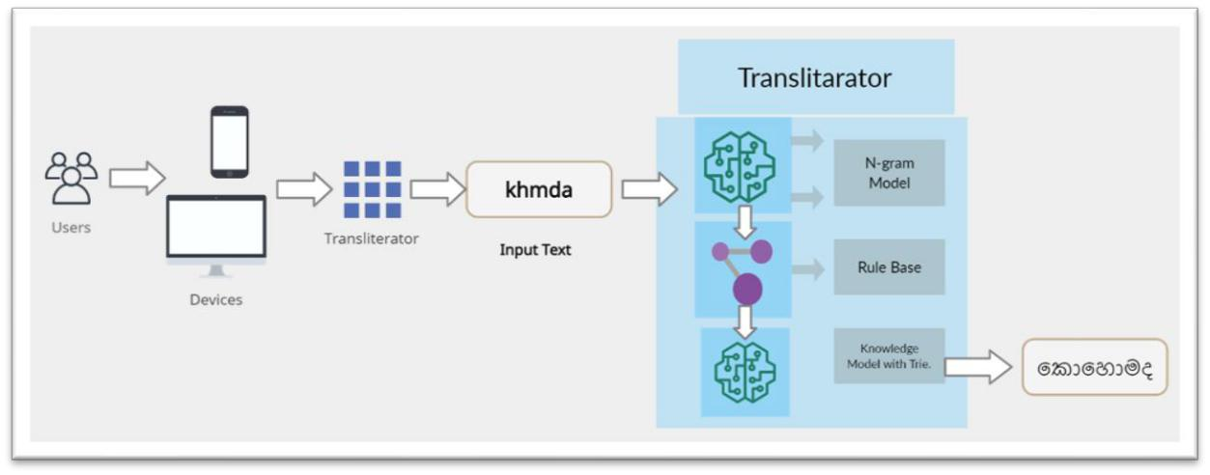

Figure 1.2 Prototype Feature Diagram of Transliterator (Self-Composed)

1.15 Chapter Summary and Structure of the dissertation

This chapter discusses the background. The introduction has been discussed. The existing work was discussed and based on the findings latest research work has been focused on Classical transliteration techniques. Therefore, the research gap was formulated by contributing a novel transliteration schema for the Romanized Sinhala to Sinhala. The objectives and aim of the

10
research has been discussed and main research objectives were identified. The outline of the structure of the dissertation is as follows.

Chapter 01 | Introduction | This chapter establishes an overview of the research
 |  | project. The background of the research, scope,
 |  | requirements, and objectives are detailed in this chapter. In
 |  | nutshell, this chapter defines the problem, limitations of the
 |  | currently existing systems, and other contributing factors.
Chapter 02 | Literature | The literature review chapter will provide the related
 | Review | information on this study. Domain and Technical review
 |  | with existing systems, algorithmic analysis, and evaluation
 |  | methodologies are discussed. A literature review of the
 |  | domain and the technology has been discussed as the major
 |  | factors.
Chapter 03 | Methodology | The methodology chapter provides a run-through of the
 |  | research, project, and development methodologies selected
 |  | to continue this research. Furthermore, identifying
 |  | stakeholders, the outline of gathering requirements, and
 |  | analyzing gathered information to identify and priorities
 |  | the requirements are to be discussed. Initially, a rich picture
 |  | diagram was drawn specifying the internal and external
 |  | environments of the project that gives an overview of the
 |  | stakeholders of the project.
Chapter 04 | Implementation | The implementation chapter provides an overview of the
 |  | technology stack and algorithms used in the
 |  | implementation.
Chapter 05 | Evaluation and | The evaluation and results chapter provides an overview of
 | Results | The evaluation and results chapter provides an overview of
 | Results | Quantitative evaluations and Qualitative evaluations based
 |  | on feedback collected from domain experts, technical
 |  | experts, academic experts, and researchers for different
 |  | aspects of the research and prototype. Functional and non-
 |  | functional requirements will be evaluated to ensure that
 |  | 11

 |  | system meets the expected requirement. The Numerical
 |  | evaluation is presented in the chapter.
Chapter 06 | Conclusion and | The conclusion chapter discusses the project's final
 | Future Works | remarks. It analyzes whether the project aims, and
 |  | objectives were met successfully, the challenges
 |  | encountered and the limitation with future works. The
 |  | research contributions to the domain and computer science
 |  | are presented.

12
CHAPTER 2

LITERATURE REVIEW

2.1 Chapter Overview

The literature review chapter will summarize the related information on this study. The chapter contains a domain with the existing systems, algorithmic analysis, and evaluation methodologies currently available in the literature. The chapter will mainly divide into a literature review of the domain and the technology to provide a much better analysis of the domain and the technologies. And the chapter will address the existing systems and approaches that have been used to provide a better architecture in the transliteration process in both Sinhala and other languages. This information will justify selected approaches to develop the proposed system while providing the required knowledge for the project.

2.2 Problem Domain

2.2.1 Introduction to Natural Language Processing

Natural Language Processing (NLP) is a known technology used by researchers to implement linguistic-based systems. Along with artificial Intelligent (AI), NLP can provide speech and text translation ability to computers. Humankind behaviour can be integrated with the help of context.

According to figure 2.1, the first component of the study will be morphological Processing. The inputted text will separate into paragraphs, sentences and word-level tokens. This process is known as tokenizing. The syntactic relationship among the sentences is analyzed using the syntax analyzer chapter. The semantic analysis which the third chapter uses to analyze the meaning of the sentences. The real meaning can be extracted using the pragmatic analyzer.

Ambiguity is the main concern in the domain of NLP. For example, if a sentence says, “John saw Jane at the bank with a dog”. But it is difficult to explain who is with the dog. It may John, or it may be Jane. And also, the bank can be a financial bank or riverbank. So identifying the correct meaning of the word is essential. The pragmatic analysis chapter is an essential section of the NLP to solve this ambiguity in the translation processes (Diksha Khurana et al., 2017).

13
The multiple techniques used with NLP like Pos-Part of Speech tagging, Speech detection, Natural Language Generation, Co-reference resolution, Sentiment Analysis, Word entity recognition and the sense of words disambiguation (Education, 2020) can fulfil the task of building a proper mankind system. This domain provides the user to build a sustainable system in machine translation and Transliteration.

2.2.2 Machine Translation

Machine Translation (MT) also known as Automated translation is a well-structured systematic process which can use to translate a source language to a targeted language. The oxford dictionary says Machine translation is a process that is carried out the process of translation using a computational technique. According to Figure 2.2, the input to the system is sources text which will be divided according to its type of difficulty based on the preprocessing. The difficulty level relies on assumptions, expectations, and relations. The Text needs to
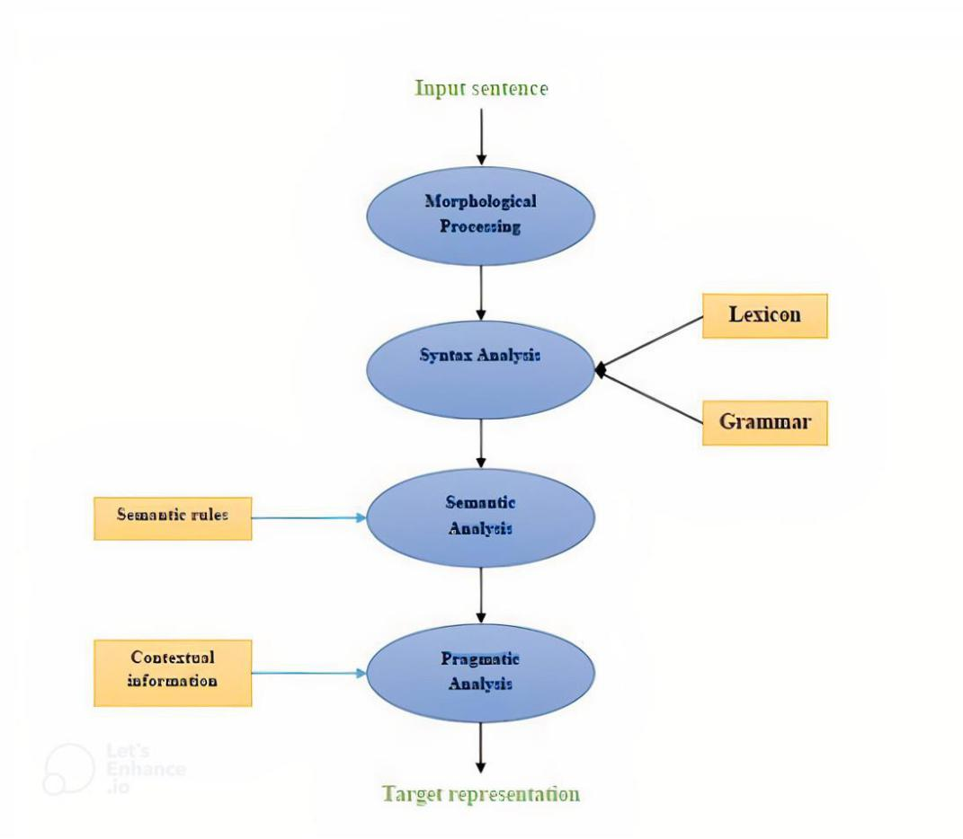

Figure 2.1 Translation overview

14
reformat once the translation is completed. Removing unnecessary tokens through the preprocessing and post-editing performed over the text will enhance the translation quality of the text. Two phases will control the efficiency level of an MT system. Analysis and generation of processors of the Morphological Syntactic and Semantics will do a huge contribution to the translation process. The morphological properties such as tense, grammatical form, gender, and mood will be considered about the structure of the word. And the analyzation phase and fine-tuning in the initial phase. In the Syntactic analysis phase, the Part of Speech(pos) tagging will be considered. The single token generated from the tokenizer in the syntactic phase will use lexical features in a language such that the lexical elements in each language will be analyzed concerning the language. Grammar Formalism frameworks in Machine translation will describe the structure of a language. Such frameworks are developed for different languages based on the requirement of the translation process. (Robin, 2010). Machine Translation has various types such as Statistical, Rule-based, dictionary-based, knowledge-based, example-based, and hybrid-based approaches that combinedly can be used for efficient translation and transliteration. (Okpor, 2014).

2.2.3 Computational Linguistics

Computational linguistics (CL) is the study of languages based on a computer perspective which can be derived using a scientific manner. The understanding of the writing and spoken languages are addressed in the CL domain. This is an interdisciplinary field connecting with computational modelling and NLP. CL provides language models such as knowledge-based, and data-driven. Theoretical computational linguistics includes grammar and semantics often grounded in symbolic and formal logic. Applied computational linguistics mainly branched with machine learning was discussed in the mid-2010s but with the evolvement of deep learning in 2015, it became a major framework for NLP. In terms of the NLP domain, Computer linguistics gives a vast experience in many systems. Web search engines, Text-to-speech synthesizers, and text editors are some examples of those systems. (ACL, 2020)

15
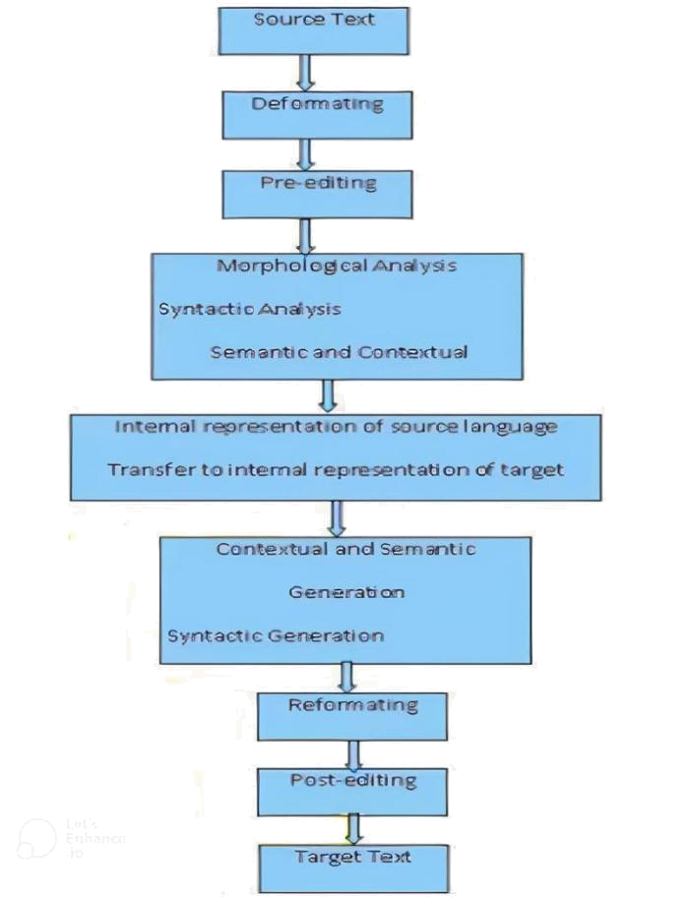

Figure 2.2 Machine Translation

2.2.4 Sinhala Language

Sinhala, the major native language of the Sinhalese people of Sri Lanka who is the largest ethnic group of the county is considered a language which belongs to the globe-spanning language tree, Indo-European. (de Silva, 2021) However, due to poverty in linguistic resources, Sinhala remains a resource-poor language compared to many other existing languages. A number of research communities have engaged in numerous researched and experiments to enhance the research value of the language. However, due to various reasons, these attempts seem to lack coordination and awareness of each other.

16
The Sinhala language is considered to be the mother tongue of approximately 16 million people (de Silva, 2021) where the writing pattern for Sinhala originated form Indian Brahmi script. When considering the usage of the Sinhala language, the basic grammar related to the language can be interpreted using 2 formats, where one for written(literacy) and other for spoken. The written format follows Subject Object Verb (SOV) configuration where subject verb agreement is introduced to the structure of the language which produces a grammatically correct sentence based on gender, number, and person. In each category the verb of the particular sentence is decided based on gender: male or female, number: Singular or plural and person: 1st, 2nd or 3rd. But in the speaking context of the Sinhala language SOV order can be neglected. When considering the Sinhala Script, it is considered the most expansive language in the world (Vidanaralage et al., 2018) which contain 60 letters including 18 vowels, 42 consonants. But with the letter “ඥ” total no of character to be considered on 61. In Sinhala speaking style it represents 40 phoneme sounds with 14 vowels and 26 consonants sounds. However, based on the study many researchers have used phonetic chart for Sinhala and Sinhala translation chart which are represented in figure 2.3 and figure 2.4.
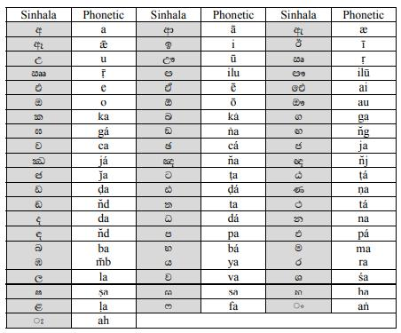

Figure 2.3 Phonetic Chart for Sinhala Alpahabet

17
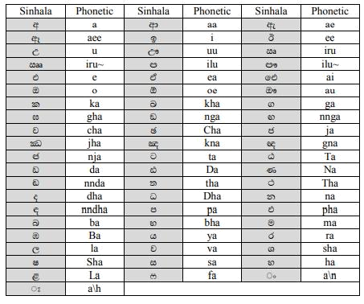

Figure 2.4 Sinhala transliteration Chart

2.2.5 Romanized Sinhala

Typing native Sinhala using English script is known as Romanized Sinhala. According to (Hettiarachchi et al., 2020) the word “අම්ො” can be represented as “Amma” with the usage of Romanized Sinhala. Instead of using letters related to the same language, a convenient language which is mainly English can be used to represent the word, where phonetics is the same and reading is the same. (Liwera and Ranathunga, 2020). With the development in social media platforms, the Sri Lankan community tends to use Romanized Sinhala for social media chatting and commenting.

Table 2.1 Most Common typing patterns in Romanized Sinhala

Sinhala Word | Pronunciation | Romanized Sinhala
ෙෙ වගදර යනවා | mama gedara yanavā | Mama gedara yanwa
වම් ෙහා කරදර කාලයක් | mē mahā karadara kālayak | Meh mahaa karadhara
 |  | kaalayak
ොජ ොධ්‍ය මිනි ්ුවිනාශ | samāja mādhya minissu | Samaaja maadhya minissu
කරනවා | vināśa karanavā | winaasha karanwa

18
2.3 Existing Work

With the technological and social revolution, many translation algorithms have been discovered globally. Sri Lanka as the only country that speaks Sinhala has some systems with various computational approaches on Sinhala Language even the language is considered as a low resourced. Existing machine translation-related systems and their technological review will be discussed in the below sections mainly focusing on following two Machine translations (MT) Approaches.

- Machine Translation with Sinhala

- Machine Translation with different languages.

2.3.1 Technology and Algorithms Review

Rule-Based Approach

The rule based (RBMT) approach was the first to be implemented, and it focuses on well-defined rules related to the source and target languages. The main approaches in the Rule-based are Direct MT, Transfer-based MT, and Interlingual MT. This approach is known to be complex in terms of effort, time, and complexity because it requires the production of linguistic rules for the translation from the source sentence to the target sentence.

Rule based approach (RB) can be performed in three phases. The Analysis phases perform while the source sentence inserted where next phase of the Transfer phase will be used in the source sentence translation into the target sentence and the final phase which is the generation phase will generate the output with the relevant grammatical rules. After inserting the source text into the system, the process moves on to the morphological analyzer, Part-of-Speech tagger (POT), lexical selection, transfer structure/lexical, morphological generator, and finally the post generator for the target language. This method focuses on the structure of both the source and target languages where the structure of the source language must be linked to the structure of the target language. As a result, RBMT employs a set of grammatical rules that can be applied to any language. Figure 2.5 depicts the basic architecture of the RBMT approach.

19
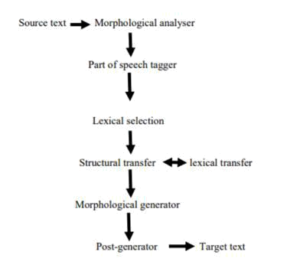

Figure 2.5 Rule Based Architecture

According to the available literature there are many developed systems which use rule-based approach. In many of cases, rule-based system has been used for the translation process of the formal work, which means for the systems which can be used in the official translations. The latest research work by Silva (Silva and Ahangama, 2021) has used rule based approach to Transliterate Singlish to Sinhala which uses an error-correcting module. The defined rule has been used to transliterate in the syllabic level which generated words are fed to the error correcting module which implements using Sinhala corpus The RBMT approach was used by A.J. Vidanaralage and the team to implement the English-Sinhala Decoder (A.J. Vidanaralage, 2018). They used a wordlist dictionary of both Sinhala and English words, as well as a set of rules, to generate meaningful target language sentences. The entered sentence (source sentence) is divided into Tokens (single words) in this system, and the morphological information of each word is analyzed using a dictionary. The Hindi-English Translator (Omkar Dhariya, 2017), a system developed by Omkar Dhariya and his team, made use of the RBMT. In the above translator, the RBMT also acts during the rearrangement phase, as well as selecting the correct nouns and tagging (PoS) using the parallel Hindi and English dictionaries.

The source language sentence (Hindi) will rearrange by using appropriate grammatical rules and produce the correct target sentence (English). The latest research by Liwera which converts Singlish to Sinhala using N gram approach use Rule based approach for the last phase of the transliteration process. The rule used for transliterating Singlish to Sinhala based on a character level is not accurate according to the results of the study.(Liwera and Ranathunga, 2020). The latest research by (Silva and Ahangama, 2021) with the error correction module uses the rule

20
base approach for the transliteration task where the research is handling special characters like mahaprana, thaluja Characters in the Sinhala Alphabet. The main drawback of the approach is translation or transliteration process has fully relied on the defined set of rules. The latest commercial product Helakuru uses the same Rule based mechanism for their Keyboard where each character follows a defined typing pattern to transliterate in the desired character.

Statistical-Based Approach

One of the well-known approaches to MT is the statistical-based approach, which works primarily by understanding the grammatical aspects of the source and target languages. Most of the time, these statistical-based MT systems access the work with a very little number of interactions with dictionary entries and language-related resources. To facilitate training, these systems typically break sentences down into n-grams. This will eventually improve the system's accuracy and performance. From a development standpoint, training can be accomplished by increasing the number of entries in many translation scenarios. The Trigram, Bi gram and Uni gram models used in this architecture can escalate the productivity and the credibility of the results generated. The author of this work uses a ngram model to build the initial phase of the transliteration process. According to the research done on the literature using Statistical approaches, it can justify that this approach is most suitable in terms of accuracy without consuming much time and financial aspects. Google translator is one of the best examples. (Rajpirathap S, 2015).

- Character N gram

Though character n gram features were considered in text classification problems they were used only in a few number of works in the Translation domain (Liwera and Ranathunga, 2020). Character n-grams can detect character patterns in texts where misspelt words can be captured in the approach. Since code-mixed texts contain different spelling variations n gram model will be efficient for a credible answer. Character n gram features were used for feature extraction in many of the studies according to the literature.

- Word N gram

Word n-grams performed well in text classification and Transliteration since natural languages are not just words but words with structures. N gram model which is trained using word level n gram cannot avoid ambiguity in the translation and transliteration process as these models are not much focus on the meaning of the sentence but the syntax. The researcher liwera has used

21
Word level trigram, Bigram and Unigram for his study where accurate translation has been achieved in the study.

Example-Based Approach

Makoto Nagao founded the example-based approach as an MT-based approach in 1981. Example-based machine Translation consists of three major components: matching and testing of the separated information from the source language, identification of the separated information for translation, and combination of the separated translated information into the target language. The benefits of using this EBMT approach include the ability to use the methodology in any pair of source and target languages, which can improve the results depending on the example set available for the language model.

Knowledge-Based Approach

One of the domain-specific Machine Translation strategies is knowledge-based approach. This method has been applied to integrate machine translation associated systems during translation. When it comes to creation, this method mostly relies on ontologies and the semantic web. Nair and his team adopted Knowledge based approach in their hybrid approach (Nair et al., 2016), but this is not well explored in the literature.

Neural-Based Approach

The neural-based approach is a newly added approach to the MT-based approach family. The main difference and advancement in this Neural based approach among all the existing approaches are translation is done using a neural network. The long words sequences and short word sequences are well handled in many Neural models. The latest research has been performed using this approach with the use of encoder and decoder architecture in the translation process (Sandaruwan et al., 2021). Encoding will be directed at the source sentence and will result in a fixed-length vector. The decoder will then generate the translation to the target sentence. LSTM, Transformers like Bert and Roberta are well-known neural models for machine translations.

According to the study of Sandaruwan and the team(Sandaruwan et al., 2021), the Seq2Seq model with Recurrent neural network or LSTM were frequently used in the Neural based approaches. Seq2Seq model, Transformers and Seq2Seq model with attention mechanism are much researched in recent history concerning the translation and transliteration domain. Meta

22
MT, which is a meta-learning approach for Low resources language are addressed under the Neural approaches which contain model parameters and Meta parameters for fast domain adaptation.
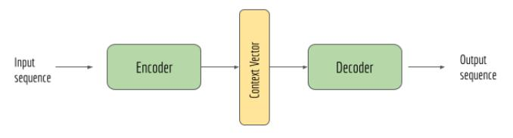

Figure 2.6 High-level encoder decoder Architecture

Hybrid Approach

The hybrid approach is one of the latest approaches in MT approaches. This will be implemented using the combination of two or many existing MT-based approaches. Two or more approached discussed in the above sections will be used in the approach where accurate answers will be produced using the approach. (Nair et al., 2016)

2.3.2 Comparison of the Algorithms

Table 2.2 Algorithm Comparison

Algorithm | Improvements |  |  |  |  | Limitations
Rule- | • The translation has primarily |  |  |  |  | • | A no of rules need to be
Based/Knowledge | been based on the vocabulary |  |  |  |  |  | implemented.
Based Approach | conventions of the source and |  |  |  |  | • Lack of resources and datasets.
 | target languages. |  |  |  |  | • The development of proper data
 | • The ability to use dictionaries |  |  |  |  |  | sets for the process is complex.
 | and grammar in both bilingual |  |  |  |  | • It is more difficult to manage
 | languages | to | find | pertinent |  |  | therulesinlarge-scale
 | lexical information. Start with |  |  |  |  |  | initiatives.
 | the analysis, move on to |  |  |  |  | • | Need numerous rules for the
 | transfer, | and | finish |  | with |  | proper translation process.
 | generation | by | following |  | the | • | Costly, | time-consuming
 | three main basic stages. |  |  |  |  |  | approach and need more human
 | • A thorough analysis based on |  |  |  |  |  | effort.
 | syntactic | and |  | semantic
 | analysis is necessary.
 |  |  |  | 23
 |  |  |  |  |  |  |  | • Deep |  |  | linguistic knowledge is
 |  |  |  |  |  |  |  |  | required.
Statistical | Based | • | Used a corpus-based bilingual |  |  |  |  | • Bilingual data need to be
Approach |  |  | lexical on both Source and |  |  |  |  |  | managed, So the complexity is
 |  |  | target. |  |  |  |  |  | high.
 |  | • | No complex ontology |  |  |  |  | • | For | languages |  |  |  | with | a | small
 |  | • Reusability is |  |  | higher |  | as |  | number of |  |  | parallel resources,
 |  |  | training data can be used with |  |  |  |  |  | there is a lack of viability and
 |  |  | similar projects. |  |  |  |  |  | the feasibility
 |  |  |  |  |  |  |  | • The |  |  | word | formatting and
 |  |  |  |  |  |  |  |  | arrangements |  |  |  | are different |  |  |  | in
 |  |  |  |  |  |  |  |  | native |  | languages. |  |  |  | So, | the
 |  |  |  |  |  |  |  |  | flexibility of the adaptation of
 |  |  |  |  |  |  |  |  | the system is low.
Example | Based | • | The ability to find the output |  |  |  |  | • The meaning of the generated
Approach |  |  | using raw input data. |  |  |  |  |  | output might not meet the
 |  | • If the matching percentage is |  |  |  |  |  |  | expectations.
 |  |  | high, it will be possible to |  |  |  |  | • The shortage of efficient texts is
 |  |  | deliver structured output in a |  |  |  |  |  | required for the process.
 |  |  | better | way | by | utilizing |  | • Scalability of the scope in the
 |  |  | examples. |  |  |  |  |  | translation |  |  |  | process |  |  |  | in
 |  |  |  |  |  |  |  |  | challenging.
Neural | Based | • | Both source and Target can be |  |  |  |  | • The speed of training models is
Approach |  |  | fed to a single model for the |  |  |  |  |  | too slow and time-consuming.
 |  |  | training. |  |  |  |  | • | High |  | Computational |  |  |  | power |  | is
 |  | • One efficient |  |  | model |  | can |  | required for the training.
 |  |  | translate the source to Target. |  |  |  |  | • | Ambiguity |  |  | in | the word |  |  | level
 |  | • Efficient |  | outputs |  | can | be |  | transliteration |  |  |  |  | needs | to |  | be
 |  |  | gathered. |  |  |  |  |  | addressed separately.
Hybrid Approach |  | • | Provide | better | efficiency |  | in |  | • | Selecting the most suitable
 |  |  | the translation process, |  |  |  |  |  |  | models |  | for |  | the | Hybrid
 |  | • Better |  | Flexibility |  | in | the |  |  | approach is challenging.
 |  |  | translation process. |  |  |  |  |  | • | Experiments |  |  |  | need to |  |  | be
 |  | • | Good accuracy. |  |  |  |  |  |  | done on model selection.
 |  |  |  |  |  | 24
2.3.3 Tools and Techniques

There are various toolkits and libraries available for the MT process in NLP. Among them,

- The system can be implemented using the well-known open-source package "Natural Learning Toolkit (NLTK)". The following tools have been incorporated into this toolkit: sentence parsing, word segmentation, stemming, lemmatization, tokenization, N-gram tagging, and semantic reasoning. To support the rule-based approach, this toolkit also includes lexical analysis, named entity recognition, tokenization, POS tagging, parsing, and semantic reasoning.

- Sentimental analysis plus flexible models, content localization, event extraction, and intent analysis can be performed using TextBlob which is a fast tool derived using the functionalities of NLTK.
- The well-known data and sentiment analysis library "Stanford" is also used for NLP. For developers, this package also offers a wide range of NLP-based tools. This has a unique quality called "scalability." Developers may process a lot of data with less complex operations by using this module. Large-scale systems are a wonderful fit for this library. This tool's parser is widely used in translation-related applications. For the study, the English-Hindi Machine Translation (Nair et al., 2016) this module has been used.
- The Google Translation service seems to be the methodology that has been employed in the majority of translation systems. This method was applied in the Sinhala Decoder (2018) (Vidanaralage et al., 2018) translation of the source text.

- The translation method was developed using a variety of wordnets, databases, and dictionaries connected to different languages. The Sinhala Decoder (2018) (A.J. Vidanaralage, 2018) employed a lexicon of 70,000 terms in both English and Sinhala definitions to create the system. In other circumstances, the researchers must gather the necessary data sources from a variety of outside sources, including records and official papers. To avoid data inadequacy, the Si-Ta system (2018) (Ranathunga et al., 2018) has utilised data from government-related circulars, establishment codes, annual reports, and parliament-related order papers.

- Python is the primary language that can be utilized for implementation. In addition to Python, R, C#, and Java are all utilized to do a variety of tasks. However, a significant number of libraries, such as the NLTK toolkit, are readily available.

25
2.4 Chapter Summary

The literature review of the proposed architecture for Romanized Sinhala to Sinhala Translation is mainly separated into sections as the literature review of the domain, Existing works, and technology to discuss and justify the relevant aspects of the proposed system. Each section of the Literature review attempts to provide a clear idea of the current technologies and the existing systems which can be used for the study. It has been observed that the Transliteration process for Romanized Sinhala to Sinhala is less researched in History and the available approached are not accurate for a better typing experience. So, by identifying the drawbacks related to the current systems the author of this work will be performing research on Transliteration using statistical-based approach and Neural based approach. The chapter concluded with a summary. The next chapter will be discussed the methodology of the research project

26
CHAPTER 3

METHODOLOGY

3.1 Chapter Overview

This chapter provides an overview of the research, project, and development methodologies selected to continue this research. Furthermore, identifying stakeholders, the outline of gathering requirements, and analyzing gathered information to identify and priorities the requirements are to be discussed. Initially, a rich picture diagram was drawn specifying the internal and external environments of the project that gives an overview of the stakeholders of the project. Further, it consists of an analysis of different approaches followed by requirement elicitation. Use case diagrams and descriptions, and functional and non-functional requirements are specified.

3.2 Research Methodology

The research methodology section allows stakeholders to evaluate the validity and reliability of a research project critically. The Saunders research visualizes the different stages of the research work. The selection and justification for each selection are listed in the below table.
Philosophy | Positivism will be used where quantifiable observations and
 | measurements will use for statistical analysis and Transliteration Schema
 | will be implemented based on your users’ comments.
Approach | A Deductive approach will be used with the research as the intention of
 | the system is to use the existing theory to enhance the Transliteration of
 | Romanized Sinhala to Sinhala. To analyze the data quantitative approach
 | will be used.
Strategies | The primary method of collection of data will be a quantitative strategy
 | where a questionnaire will be used to identify the typing patterns. As the
 | second strategy interviews with domain expertise will be followed, where
 | a Qualitative approach to verify the data. To have a wider idea of the
 | transliteration scheme social media comments will be taken into
 | consideration.

27
Choice | A mixed method is used as survey data must be validated with the
 | interviews. So quantitative approach will be followed by a qualitative
 | strategy.
Time | Data will be collected in the requirement engineering and evaluation
Horizons | phases in this research and will not repeatedly be collected. Hence, cross-
 | sectional will be used
Techniques | Questioners, interview data, reports that are published, records
and other | related to Sinhala linguistics, and statistics will be used to validate the
procedures. | research project.

3.3 Development Methodology

Time, Cost and Scope must be managed properly in a research project. Thus, the development process should be structured properly with the changes in the requirements to manage cost and time. Methodologies like waterfall, agile, Rapid Application Development, RAD, and Spiral are used to manage the implementation process in the software development life cycle. But prototype methodology, where users are actively engaging in development is selected as errors can be found in the initial phases, missing features can be identified, and it is flexible for fluctuating requirements. Furthermore, as high evaluation interactions happen, the success of the product can be guaranteed. Hence, the prototype methodology is more suitable for this research project.

3.4 Project Management Methodology

Regardless of the type, any project has a scope, time duration, and cost as constraints. To produce quality output, it is necessary to manage these constraints. As many project-related processes must be followed in a controlled and manageable environment, the “Prince2 Agile” methodology will be used.

28

3.5 Data Collection Methodology

3.5.1 Data set Selection

The dataset with “Romanized Sinhala word” and respective Sinhala words based on social media content was found. (Liwera and Ranathunga, 2020). The processed dataset will be used to create transliterals required for the Study. The Dakshina dataset(Roark et al., 2020) from google which contains transliterations will be used to enhance the Transliteral set required for the unigram tagger.

A dataset on YouTube social media content that covers multi-categories will be created by the author of this work. The Dataset will cover a wide range of Romanized Sinhala and respective Sinhala words extracted from Social Media platforms. The face pager (Jakob Jünger, 2014) application which is freely available has been used to extract the data from YouTube. The youtube has been selected as comments are publicly available over diverse categories. Only the sentences with Romanized Sinhala will be taken into usage. The following areas are captured for the creation of the dataset.

- Social backgrounds

- Music

- Politics

- News

- Religion

- Technical

The collected dataset will be transliterated to related specific Sinhala sentences manually. Using the created dataset, the transliterals are generated which are used with Character level and Word level N-gram.

3.5.2 Data set Annotation

The online surveys are circulated among the communities to gather the typing patterns which they used to type Romanized Sinhala. Based on the 215 users' inputs the different typing

29
patterns were identified. Identified typing patterns were analyzed to build the rule required for the Data annotation algorithm discussed below. The selected 3 sentences from the below set have been shared again with the selected group of users from the initial form to analyze the changes over time. Stratified sampling was used to identify the target audience and the related typing patterns of each group.

Table 3.1 Sinhala sentences used to identify the patterns in the survey

විවිධ්‍ අව |  | ්ථාවලදී ක්ුද්‍ර ජීවීන් පාලනය හ |  |  |  |  |  |  |  |  |  |  |  |  |  | කවිවයකුවේ කවි සිතුවිේලකට ගීෙ රචකවයකුවේ
ජීවානුහරණය කිරීෙ ඳහා වනාවයකුත් ශිේප ක්‍රෙ භාවිො |  |  |  |  |  |  |  |  |  |  |  |  |  |  |  | ලයාන්විෙ ගී පබැඳුෙකට සිත්ෙවරකුවේ චෙත්කාර
කරනු ලැවේ. |  |  |  |  |  |  |  |  |  |  |  |  |  |  |  | සිත්ෙෙකට වහ්තුවූවබාවහෝ පාරි |  | රික පුබිම් දැකගෙ
 |  |  |  |  |  |  |  |  |  |  |  |  |  |  |  | හැක
 | ම්වේච්ඡ වල ඝාෙනය කර තිබූ මිනිය ැඟවීෙට උත් ාහ |  |  |  |  |  |  |  |  |  |  |  |  |  |  | ඈෙ අතීෙවේ සිට පැවෙ එන ාං |  | ්කෘතිවේඑක්
 |  |  |  |  |  | ය
 | වනාකර කෲර වල විසිකර දො තිබූ අයුරු දි ්වි |  |  |  |  |  |  |  |  |  |  |  |  |  |  | විවශ්ෂාාංගයක්වල රජදරුවන් විසින් ෙැනූ වැව් හ
 |  |  |  |  |  |  |  |  |  |  |  |  |  |  |  | දාගැේ වහළ සිාංහලයාවේ විශ්මිෙහැකියාවන් පිළිබිඹු
 |  |  |  |  |  |  |  |  |  |  |  |  |  |  |  | කරයි.
 | ඓතිහාසික වටිනාකෙකින් යුක්ෙ වූ ඒ ෙහා වබෝධීන් |  |  |  |  |  |  |  |  |  |  |  |  |  |  | බටහිර වවදය විදයාවව් ඇෙැම් හිඩැ ්ඌන පූර්ණය
 | වහන්ව | ්කපා දැමීෙට ෙැත් කළ සියලු වදනා හට |  |  |  |  |  |  |  |  |  |  |  |  |  | කිරීම් ඳහා ආයුර්වව්ද වල වයාදා ගන්නා ඖෂධ්‍ ෘජුවෙ
 | ්වභාවධ්‍ර්ෙයාවිසින් දඬුවම් ලබා දුනි |  |  |  |  |  |  |  |  |  |  |  |  |  |  | ඕනෑ වීෙ ඒවාවේ ඇති ඵලදායි බව පැහැදිලි කරයි.
 | ප්‍රථෙ වොවට පන් ේට පිය නැගු පාංචි ෆාතිො ඝන්ටාරය |  |  |  |  |  |  |  |  |  |  |  |  |  |  | වකාම්පඤ්ඤවීදිවේ පාංචි සිඤ්වඤෝ,ෙඤ්වඤාක්කා
 |  |  |  |  |  |  |  |  |  |  |  |  |  |  |  |  |  |  |  |  | ්
 | නාද වකාට ඉන්පුව ඊෙලයක් ව ්දිව ගිවේ බුදු ෙැදුරටය |  |  |  |  |  |  |  |  |  |  |  |  |  |  | අරන් කඩෙණ්ඩියට යන ඥානපාල ට කො කවළ
 |  |  |  |  |  |  |  |  |  |  |  |  |  |  |  | වි ්කිරිඤ්ඤාවදකක් වගන්න ගන්න.
 | වේශපාලන හැලහැප්පීම් ෙැද පලිගැනීම් පෙණක් අරමුණු
 |  |  |  | ්
 | කරගත් | ොජයක, කන්නන්ගර ෙහො නිදහ
 | අධ්‍යාපනය හඳුන්වා වදමින් කළ ව ්වාවඉෙහත්ය.

The identified patterns from the data collection chapter were used to create the data annotation algorithm which could create the Romanized Sinhala word with different typing patterns and its Sinhala word. The vowel arrangement, Consonant with Vowel usage, and the same English consonant for different Sinhala characters were identified and Rules were written. Rule-based transliterator which converts Sinhala to general Romanized Sinhala uses 60 rules for vowels and consonants, 18 rules for hal symbols, and 18 rules for special characters. The generated generalized Romanized Sinhala words were fed to the Adhoc generator which contains 12-character pattern-related rules, 6 vowel combination-related rules and 8 special character rules. The Adhoc transliteral generator will generate the Adhoc Romanized Sinhala Dictionary which will be used for the training of Trie structure. The annotation algorithm which builds upon the identified rules was used with a Sinhala Dictionary collected from the NLP society of the

30
University of Colombo to have a complete dataset for the process. The flow of the data annotation process and the selected rows from the dataset are as follows.
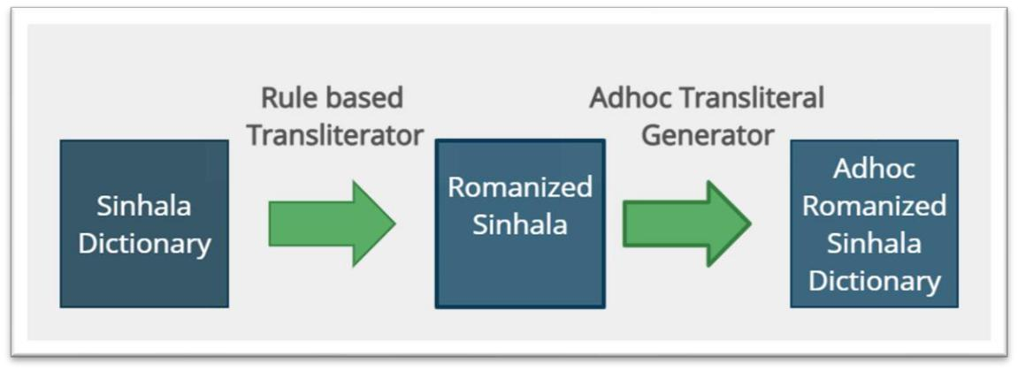

Figure 3.1 Adhoc Transliterals generation

The Transliterated algorithm was tested with the LTRL Sinhala word list under UCSC Sinhala Corpus and all possible transliterals were generated. The generated results were evaluated using qualitative analysis and adapted with a Back transliterator. Some instances from the generator are as follows.

Table 3.2 Results of data annotation algorithm

වකාවහා | kohomada,khomada,kohmada,kohomda,kohomad,khmada,khomda,khomad,koh
ෙද | mda,kohmad,kohomd,khmda,khmad,khomd,kohmd,khmd
කියන්න | kiyanna,kiynna,kiyann,kiynn,kynna,kynn,kyann
පෙණක් | pamanak,pmanak,pamnak,pamank,pmnak,pmank,pamnk,pmnk
යන්න | yanna,ynna,yann,ynn

3.6 Requirement Elicitation

Elicitation Techniques | Summary
Observations | The researcher of the work has conducted a thorough review of the
 | existing commercial products which can back transliterate
 | Romanized Sinhala to Sinhala. The following observations have
 | been taken into consideration when defining the research gap.
 | • The existing commercial products use ruled based
 | mechanism where character level transliteration schema is
 | used.
 | 31

 | • The Ad-hoc transliteration schemas are not supported by
 | many of the transliterators.
 | • Suggestion level accuracy is bit low and suggestions are
 | depending on the character level order.
 | • Character level ambiguity is not handled in many of the
 | products.
Literature Review | Conducting a Literature Review is important to identify the
 | existing products and algorithmic approaches currently available
 | in the literature. The detailed summary has been discussed under
 | the Literature review chapter and the summary is as follows.
 | • As Sinhala is a low-resource language, the existing
 | approaches' accuracy is low.
 | • The latest research work by Liwera (Liwera and
 | Ranathunga, 2020) which uses the N-gram method has
 | given a reasonably good accuracy in the transliteration but
 | which limited to a specific domain.
 | • The Neural approach used by (Sandaruwan et al., 2021)
 | used the Seq2Seq model in the transliteration process to
 | convert Singlish to English. As an intermediate process,
 | the back transliteration of Singlish to Sinhala is achieved.
Survey | According to the selected deductive approach, the researcher of
 | the work has surveyed to identify the writing patterns of a diverse
 | community. The survey is created in such a way that all the
 | Sinhala characters and their transliterals are captured. The survey
 | form and the results are attached to the appendix.
 | By analyzing the responses, the rules required for the neural model
 | will be generated and used in the transliteration process.
Interviews | The Qualitative data for research is necessary to make decisions
 | on research. The domain experts on the NLP who work in the area
 | has interviewed and valuable insight into the product has been
 | captured. The proposed model has been discussed with the experts
 | and their view and suggestions have been considered for the
 | finetuning of the model architecture.
Brainstorming | Brainstorming is important to analyze the available techniques and
 | 32

come up with an accurate architecture. With the experts’ opinions and Literature findings, using brainstorming the novel hybrid architecture has been introduced.


3.6.1 Discussion on findings from Requirement Elicitation techniques.

- Literature review

By performing thorough research on the literature, the existing technological contribution to the field of transliteration has been discovered. A detailed discussion of the findings is discussed in the Literature review. The following sections have been identified.
  - Rule based approach.

  - Statistical based approach.

  - Knowledge based approach.

  - Example based approach.

  - Hybrid based approach.

- Interview

The one-to-one interviews have been conducted with the technical experts in the area and the following has been captured.

Theme | Review/Conclusion
Dataset collection | Most of the interviewers suggested using a dataset which contains
 | data from diverse communities.
 | Suggested to use of comments in social media such that different
 | typing patterns can be captured.
Transliteration | Some of the interviewers proposed using statistical approach than
algorithm. | rule-based approach.
 | Suggested capturing both personalized typing patterns for the
 | transliteration process and the general rule used by the commercial
 | product.

33
Use of visual artifacts | Many interviewers suggested to use simple GUI which contains
in the GUI | the Sinhala and Romanized Sinhala Text in a one window.
Sinhala characters and | Some of the interviewers who were working in the Sinhala domain
Typing patterns | pointed the letters which make ambiguity in the transliteration
identifications | process.
 | Suggested to use a open survey with a diverse community such
 | that all the Sinhala alphabets and it’s Romanized Sinhala are
 | captured.

- Survey

The survey was conducted in two-time phases. The changes on typing style over the time have been identified in the different phases. The users are shared with an online survey with contain 9 Sinhala sentences covering all the Sinhala alphabet and it’s consonant and vowel patterns. The following results were obtained from the survey.

Sinhala |  |  | Selected User Inputs from Users |  |  |  |  |  | Achieved
Sentences |  |  |  |  |  |  |  |  | knowledge
විවිධ්‍ | අව ්ථාවල දී |  | Wiwida awasthawala di kshudra jeewin palanaya saha |  |  |  |  |  | Letter-wise
ක්ුද්‍ර | ජීවීන් | පාලනය | jeewanuharanaya | kiriima | sadaha | noyekuth | shilpa | krama | transliterals
හ | ජීවානුහරණය |  | bhawitha karanu labe |  |  |  |  |  | identified.
කිරීෙ |  | ඳහා |  |  |  |  |  |  | identified.
කිරීෙ |  | ඳහා | Wiwida awasthawaladi kshudra jeewin palanaya kireema
වනාවයකුත් |  | ශිේප | sandaha noyekuth shilpa krama bhawitha karanu lebe. |  |  |  |  |  | Ambiguity letters
ක්‍රෙ | භාවිො | කරනු | Wiwidha awasthawala Dee |  | kshudra | jeewiin paalanaya Saha |  |  | Ambiguity letters
 |  |  |  |  |  |  |  |  | were identified.
ලැවේ. |  |  | jeewanuharanaya | kireema | sandaha | noyekuth | Shilpa | krama | were identified.
 |  |  |  |  |  |  |  |  | වි can be
 |  |  | bhawitha karanu labe. |  |  |  |  |  | වි can be
 |  |  |  |  |  |  |  |  | represented using
 |  |  | wiwida awasthawaladi kshdra jeewin paalnaya saha |  |  |  |  |  | represented using
 |  |  | jeewanuharanaya kereema sadaha noyekuth shilpa krama |  |  |  |  |  | V or W.
 |  |  | bhawitha karanu lAbe.
 |  |  | Vivida awastha waladi ikshudra jiwin palanaya saha |  |  |  |  |  | Vowel
 |  |  | jivanuharanaya kirima sadaha noyekuth shilpa krama bawitha |  |  |  |  |  | combinations
 |  |  | karanu labe. |  |  |  |  |  | identified.
 |  |  | wiwida awasthawaladi kshudra jeewin palanaya saha |  |  |  |  |  | identified.
 |  |  | jeewanuharanaya kirima sadaha noyekuth shilpa krama bawitha
 |  |  | krnu labe
 |  |  | Vivida awastha waladi kshudra jeeween paalanaya saha
 |  |  | jeewanuharanaya kireema sandaha noyekut shilpa karama
 |  |  | baawitha karanu labe
 |  |  |  |  | 34

wiwida awasthawaladhii shrudhdha jiwiin paalanaya saha jiiwaanuharaNaya kiriima sadhahaa noyekuth shilpa krama bhaawithaa karanu lAbee.

wiwida awasthawaladi kshudhra jeewin paalanaya saha jeewanuharanaya kireema sadaha noyekuth shilpa krama bhawitha karanu labe.

කවිවයකුවේ කවි | Kawiyekuge | kawi |  | sithuwillakata geetha |  | rachakayekuge |  | Letter | wise
සිතුවිේලකට ගීෙ | layaanwitha | gee | pabedumakata |  | siththarekuge |  | chamathkara | transliterals
රචකවයකුවේ | siththamakata heethu wuu bohoo paarisarika pasubim dekagatha |  |  |  |  |  |  | identified.
ලයාන්විෙ ගී | heka |  |  |  |  |  |  | identified.
පබැඳුෙකට | Kawiyekuge | kawi |  | sithuwillakatageetha |  | rachakayekuge |  | Vowel
සිත්ෙවරකුවේ | layanwitha gee |  | pabedumakata |  | siththarekuge |  | chamathkara | Vowel
 |  |  |  |  |  |  |  | combinations
චෙත්කාර සිත්ෙෙකට | siththamakata hethu u boho parisarika pasubim dekagatha heka. |  |  |  |  |  |  | combinations
චෙත්කාර සිත්ෙෙකට |  |  |  |  |  |  |  | identified.
වහ්තුවූවබාවහෝ | Kawiyekuge Kavi sithuwillakata Geetha rachakayekuge |  |  |  |  |  |  | identified.
පාරි රික පුබිම් | layaanwitha gee pabaendumakata siththarekuge chamathkaara
දැකගෙ හැක. | siththamakata heathy wuu boho paarisarika pasubim dekagatha
 | haeka.
 | kawiyekuge kawi sithuwillakata geetha rachkayekuge
 | layanwitha gee pabedhumakata siththarakuge chamathkara
 | siththamakata heethuwuu bohoo paarisarika pasubim
 | dhAkagatha hAka.
 | Kaviyekuge kavi sithuwillakata githa rachakayekuge layanwitha
 | gi pabadumakata siththarekuge chamathkara siththamakata
 | hethuwu boho parisarika pasubim dakagatha haka
 | kaviyekuge kavi sithuwillakta githa rachakayekuge layanwitha
 | gee pabadumakata siththarakuge chmathkara siththmkata
 | hethuwu bho parisrika pasubim dakagatha hakiya
 | Kawiyekuge kawi situwillakata geetha rachakayekuge
 | layanwitha gee pabadumakata sithareku ge chamatkaara
 | sithamatakata heethu wu boho paarisarika pasubim dakagatha
 | haka.
 | kaviyekugee kavi sithuwillakata geetha rachakayekugee
 | layaanwitha | gee |  | pabAdhumakata |  | siththarayekugee
 | chamathkaara siththamakata heethuwuu bohoo paarisarika
 | pasubim dhAkagatha hAka.
 | kawiyekuge kawi sithuwillakata geetha rachakayekuge
 | layanwitha gee pabadumakata siththarekuge chamathkara
 | siththamakata hethu wu boho parisarika pasubim dakagatha
 | haka.
 | kawiyekugee kawi sithuwillakata giitha rachakayekugee
 | layaanwitha | gii | pabadumakata |  | siththarekugee |  | chamathkaara

35
 | siththamakata heethuwuu bohoo paarisarika pasubim dakagatha
 | haka
 | kaviyekuge kavi situvillakaṭa gita rachakayekuge layanvita gi
 | pabendumakata sittarekuge chamatkara sittamakaṭa hetuvu bohp
 | parisarika pasubim dekagatha haka.
ප්‍රථෙ වොවට | Prathama wathawata pansalata piya nagu punchi fathima | Letter | wise
පන් ේට පිය නැගු | ghantaraya naada kota inpasuwa eethalayak see diwa giye budu | transliterals
පාංචි ෆාතිො | madurataga | identified.
ඝන්ටාරය නාද වකාට | madurataga | identified.
ඝන්ටාරය නාද වකාට | Prathama wathawata pansalta piya negu punchi fathima
ඉන්පුව ඊෙලයක් | ghantaraya nada kota inpasuwa ithalayak see diwa giye budu | Ambiguity letters
ව ්දිව ගිවේ බුදු | medurataya.
ව ්දිව ගිවේ බුදු | medurataya. | were identified.
ෙැදුරටය | Prathama wathawata pansalata piya naguu punchi fathima
ෙැදුරටය | Prathama wathawata pansalata piya naguu punchi fathima | ඊ can be
 | ghantaraya naada Kota inpasuwa iithalayak se Duwa giye budu | ඊ can be
 | maedurataya . | represented using
 | praThama wathawata pansalata piya nAgu punchi fathima | ee or i.
 | Ghantaaraya naadha kota inpasuwa eethalayak see dhiwa giye
 | budhu mAdhuratya
 | Prathama wathawata pansalta piya nagu punchi phathima | Vowel
 | gantaraya nada kota inpasuwa iithalayak se diwa giye budu | combinations
 | madurataya | combinations
 | madurataya | identified.
 | prathama wathawata pansalata piya nagu punchi fathima | identified.
 | gantaraya nada kota inpasuwa ithalayak se diwa giye budu
 | madurataya
 | Prathama wathawata pansalata piya nagu fathima gantaraya
 | naada kota inpasuwa eethalayak se diwa giye budu madurataya.
 | prathama wathaawata pansalata piya nAguu punchi faathimaa
 | Ghanthaaraya naadha kota inpasuwa eethalayak see dhiwa giyee
 | budhu mAdhurataya.
 | prathama wathawata pansalata puya nagu punchi fathima
 | ghantaraya nada kota inpasuwa eethalayak see diwa giye budu
 | madurataya.
 | prathama wathaawata piya nagu punchi faathimaa Gantaaraya
 | naada kota inpasuwa iithalayak see diwa giyee budu madurataya
 | prathama vatavaṭa pansalṭa piya nagu punchi fatima ghanṭaraya
 | nada koṭa inpasuva italayak se diva giye budu medurataya

36
ම්වේච්ඡ වල |  | Milechcha lesa gathanya kra thibu miniya sagaweemata uthsha | Letter-wise
ඝාෙනය කර තිබූ |  | nkra krura lesa wisikara dama thibu ayuru diswiya. | transliterals
මිනිය | ැඟවීෙට | mleeccha lesa gaathanaya kara thibuu minima sangaviimata | identified.
උත් | ාහ වනාකර | mleeccha lesa gaathanaya kara thibuu minima sangaviimata | identified.
උත් | ාහ වනාකර | uthsaaha nokara kruura lesa visitara dama thibuu ayuru disviya
කෲර වල විසිකර |  | Milichcha lesa ghathanaya kara thibu miniya sangawimata | Consonant and
දො තිබූ අයුරු දි ්විය |  | uthsaha nokara kruura lesa wisikara dama thibu ayuru diswiya | Consonant and
 |  | uthsaha nokara kruura lesa wisikara dama thibu ayuru diswiya | Vowel
 |  | Milecha lesa gathanaya kara thibu miniya segaweemata uthsaha | Vowel
 |  | Milecha lesa gathanaya kara thibu miniya segaweemata uthsaha | combinations
 |  | nokara krura lesa wisikara dama thibu ayuru diswiya | combinations
 |  | nokara krura lesa wisikara dama thibu ayuru diswiya | were identified.
 |  | MileCha lesa Ghaathaya kara thibuu miniya sAgawiimata | were identified.
 |  | uthsaha nokara kruura lesa wisikara dhamaa thibuu ayuru dhiw
 |  | wiya.
 |  | Milechcha lesa gathanaya kara thabu miniya sagavimata uthsaha
 |  | nokara koora lesa visikara dama thibu ayuru disviya
 |  | Milecha lesa gathanaya Kara thibu miniya sagavimata uthsaha
 |  | nokara kruura Lesa visikara dama thibu ayuru disviya

As above results, all the survey inputs were analyzed, and the rules required for the annotation algorithm were identified. As the second phase of the survey, the Sinhala sentence was given to the users. The email sent to the users and the forms are attached in the appendix.

Participant | Sinhala Sentence |  | Romanized Sinhala | Romanized Sinhala
 |  |  | in phase 1 | in phase 2
1 | විවිධ්‍ අව | ්ථාවලදී ක්ුද්‍ර ජීවීන් | Wiwida awasthawala | Wiwida awasthawala
 | පාලනය | හ ජීවානුහරණය කිරීෙ | di kshudra jiwin | di kshudra jeewin
 | ඳහා වනාවයකුත් ශිේප ක්‍රෙ භාවිො |  | palanaya saha | palanaya saha
 | කරනු ලැවේ. |  | jiwanuharanaya kirima | jeewanuharanaya
 |  |  | sandaha noyekuth | kiriima sadaha
 |  |  | shilapa krama | noyekuth shilpa krama
 |  |  | bhawitha karanau labe | bhawitha karanu labe
 | කවිවයකුවේ කවි සිතුවිේලකට ගීෙ |  | Kawiyekuge kawi | Kawiyekuge kawi
 | රචකවයකුවේ ලයාන්විෙ ගී |  | sithuwillakata geetha | sithuwillakata geetha
 | පබැඳුෙකට සිත්ෙවරකුවේ චෙත්කාර |  | rachakayekuge | rachakayekuge
 | සිත්ෙෙකට වහ්තුවූවබාවහෝ පාරි රික |  | layanwitha ger | layaanwitha gee
 | පුබිම් දැකගෙ හැක. |  | pabadumakata | pabedumakata
 |  |  | siththarekuge | siththarekuge
 |  |  | chamathkara | chamathkara
 |  |  | siththamakata | siththamakata heethu
 |  |  | heethuwu boho | wuu bohoo paarisarika
 |  |  | paarisarika pasubim | pasubim dekagatha

37

2

 |  | dakagatha heka | heka
විවිධ්‍ අව | ්ථාවලදී ක්ුද්‍ර ජීවීන් | Wiwida awastha | Wiwida awastha
පාලනය | හ ජීවානුහරණය කිරීෙ | waladi shudra jeeween | waladi shudra jeewin
ඳහා වනාවයකුත් ශිේප ක්‍රෙ භාවිො |  | palanaya saha | palanaya saha
කරනු ලැවේ |  | jeewanuharanaya | jeewanuharanaya
 |  | kireema sadaha | kirima sadaha
 |  | noyekuth shilpa krama | noyekuth shilpa krama
 |  | bawitha karanu labe. | bawitha karanu labe.
කවිවයකුවේ කවි සිතුවිේලකට ගීෙ |  | Kawiyekuge kawi | Kawiyakuge kawi
රචකවයකුවේ ලයාන්විෙ ගී |  | suthuwillakata geetha | sithuwillakata geetha
පබැඳුෙකට සිත්ෙවරකුවේ චෙත්කාර |  | rachakayakuge | rachakayakuge
සිත්ෙෙකට වහ්තුවූවබාවහෝ පාරි රික |  | layanwitha gee | layanwitha gee
පුබිම් දැකගෙ හැක. |  | pabadumakata | pabadumakata
 |  | sittarakuge | siththarakuge
 |  | chamathkara | chamathkara
 |  | sittamakata hethu u | siththamakata hethu u
 |  | boho parisarika | boho parisarika
 |  | pasubim dakagatha | pasubim dakagatha
 |  | haka. | haka.
ප්‍රථෙ වොවට පන් ේට පිය නැගු පාංචි |  | Prathama wathawata | Prathama wathawata
ෆාතිො ඝන්ටාරය නාද වකාට |  | pansalata piya nagu | pansalata piya naguu
ඉන්පුව ඊෙලයක් ව ්දිව ගිවේ බුදු |  | punchi fathima | punchi fathima
ෙැදුරටය |  | ghantaraya nada kota | gantaraya naada kota
 |  | inpasuwa ithalayak | inpasuwa iithalayak se
 |  | see diwa giye budu | diwa giye budu
 |  | medurataya | madurataya.


The above table illustrates the user inputs collected by 2 users during two-time frames in the study. It’s clear that the pattern of typing changes with respect to the time and the mood of the user. So, the requirement of having Adhoc transliterals in the transliteration process is required for an efficient system. So, the author of this work proposes a hybrid model which can handle this concern in typing Sinhala using Romanized Sinhala.

3.7 System Architecture and Design Overview

The proposed system architecture, Process flow and data flow in the system are analyzed in the below subchapters. The selected layered architecture, technical stack, and the proposed data flow in the system with proper justifications are discussed in the below sections.

38

3.7.1 Layered Architecture

System architecture design is crucial for its ability to achieve design goals. Therefore, suitable design architecture should be followed. An analysis of selected architecture justifications for the selection is given below.
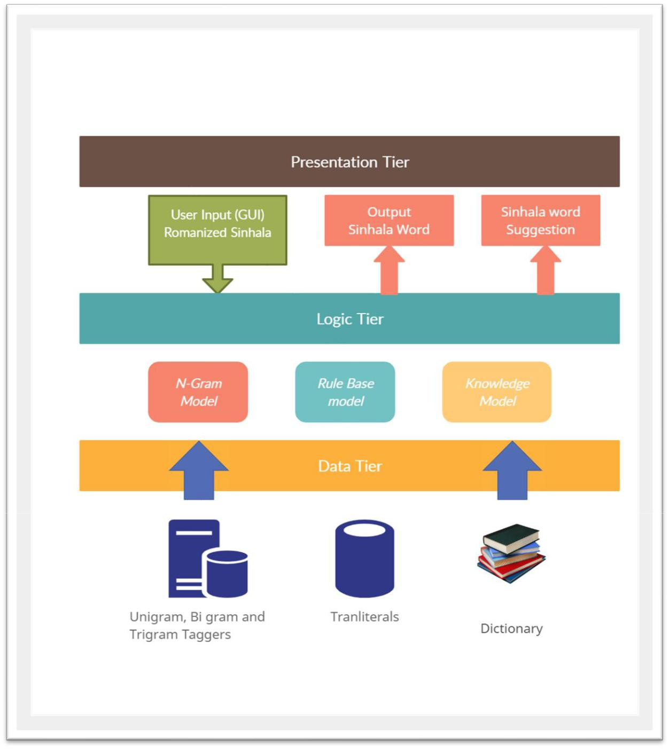

Figure 3.2 3-Tired Architecture

The proposed Model will follow the 3-tier architecture where the Components related to each section are discussed in the below table.

39

Presentation Layer | The User input wizard and the user output wizards are placed in the
 | presentation layer where all the inputs required for the system will be
 | taken through the UI Console. The Predicting level and suggesting
 | level outputs will be given to the user via the output wizard.
 | Error wizard in the presentation layer will prompt the invalid inputs
 | and unrecognized transliterations schema to users.
Logical Layer | The logic layer consists of the main 3 approaches proposed in the
 | architecture. N-gram model, Neural Model and knowledge model
 | respectively will be used in the transliteration process. Further
 | details are discussed in the algorithm’s sections.
Data Tier | The Data layer contains all the required data resources required in
 | the system. This contains all the datasets, Transliterals and the
 | knowledge base used in the study.

40
3.8 Process Flow Chart

The process flow diagram explains the process flow in the proposed model. The Usage of the Hybrid model and the manner of data flow is discussed in the below diagram.
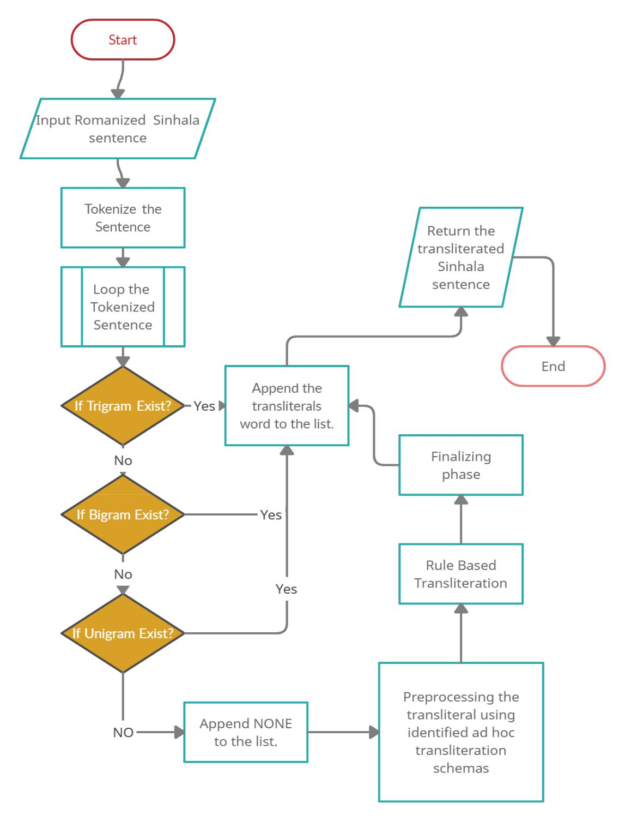

Figure 3.3 Process Flow Diagram

41
3.9 Algorithms

This section gives an overview of the algorithms used for the implementation. Further information will be discussed in the implementation section.

3.9.1 The Statistical approach with N-gram tagger.

The Romanized Sinhala sentence entered by the user will be tokenized. Each token will be checked for Trigram, Bigram and Unigrm taggers. If the transliteration is available it will be appended with the Final list where the reverse transliterated Sinhala sentence will maintain. If the expected transliteral is not found the word “NONE” will be appended to the sentence. The N-gram model is using the transliterals generated in the initial processing steps. The table represents the way of transliteral generation.

Romanized | mama | dakapu | thawath
Sinhala | nihathamani soduru |  | minisek !
Sinhala | ෙෙ දැකප ෙවත් නිහෙොනි ව ාදුරු
 | මිනිව | ක් !

mama/ෙෙ | dakapu/දැකප | thawath/ෙවත්
nihathamani/ | soduru/ව ාදුරු | minisek/මිනිව ක්
නිහෙොනි

3.9.2 The Rule base Approach

The tokens which consist of the word “NONE” after the initial process will be examined in this chapter. Each Romanized Sinhala word related to the token will be preprocessed using the pattern identified in the ad hoc transliteration schema and fed to the Rule base module. The defined rule base will be used to generate the Sinhala word required for the transliteration process.

3.9.3 The Knowledge-based approach

In this phase, the generated transliteral is examined with a knowledge-based implementation with a Trie structure. The Knowledge-based with Romanized Sinhala/ Sinhala Transliterals along with the trained model using a Trie on Romanized Sinhala will be used to produce the most appropriate word suggestion to the user. The Romanized Sinhala words suggested by the module are searched with the knowledge-based which will return all the possible Sinhala

42

transliterals to the user. So that ambiguity on the transliteration will be handled and the user has been given a choice to select the appropriate word from the suggestion pool.

3.10 UI Design

The UI Design of the proposed system is as follows. The prediction level and suggesting level UI interfaces are shown below.
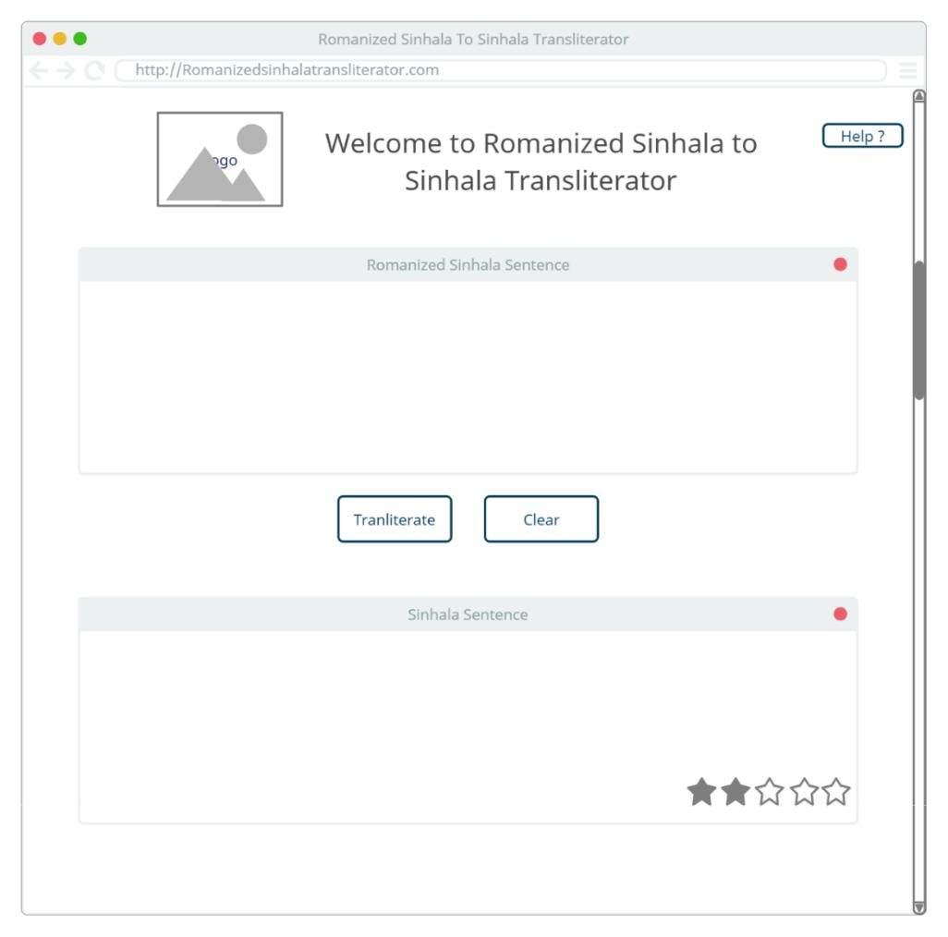

Figure 3.4 UI Design

3.11 Chapter Overview

This chapter outlines the design and architecture-related decisions and diagrams. Design goals were defined, and system architectures were defined to achieve identified design goals.

43
CHAPTER 4

IMPLEMENTATION

4.1 Chapter Overview

This chapter will provide an overview of system implementation and decisions related to the implementation. The decisions and implementation procedures benefit from the literature review results, requirement engineering and system design, and architecture.

4.2 Technology Stack

The technology stack which has been chosen to be used in various layers of the proposed system is as per the following.

Presentation Layer
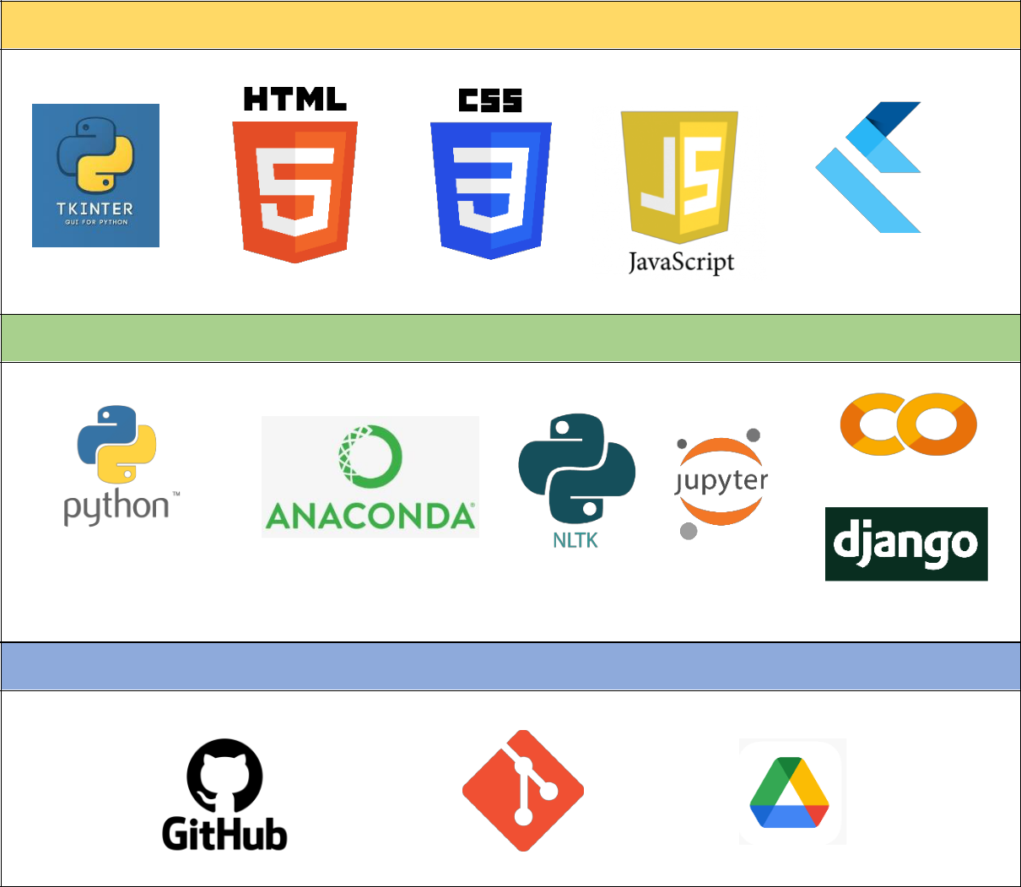

Logic Layer

Data Layer

44
4.3 Data Annotation algorithm

In this phase, the survey data were analyzed, and data were annotated using the below 2 phases.

- Rule-based Transliterator (RBT)

The Rule based generator uses to map the Sinhala dictionary to Romanized Sinhala. The following rules have been used to complete the task.

Sinhala Character |  |  |  |  |  |  |  |  |  |  |  |  |  |  |  |  |  |  |  |  |  |  |  |  |  |  |  |  |  |  |  |  |  |  | Romanized Character
 | ඌ |  |  | ඕ |  | ',' |  | ඕ |  | ',' |  | ආ |  | ',' |  |  | ආ |  | ',' |  |  |  | ඈ | ',' |  |  |  |  |  | ඈ |  |  |  | ' | 'oo','o\\)','oe','aa','a\\)','A
' ',' |  |  |  |  |  |  |  |  |  |  |  |  |  |  |  |  |  |  |  |  |  |  |  |  |  |  |  |  |  |  |  |  |  | ' | a','A\\)','ae','ii','i\\)','ie'
,'ඈ','ඊ','ඊ','ඊ','ඊ','ඒ','ඒ', |  |  |  |  |  |  |  |  |  |  |  |  |  |  |  |  |  |  |  |  |  |  |  |  |  |  |  |  |  |  |  |  |  |  | a','A\\)','ae','ii','i\\)','ie'
 |  |  |  |  |  |  |  |  |  |  |  |  |  |  |  |  |  |  |  |  |  |  |  |  |  |  |  |  |  |  |  |  |  |  | ,'ee','ea','e\\)','ei','uu','u\
'ඒ','ඌ','ඌ','ඖ','ඇ' |  |  |  |  |  |  |  |  |  |  |  |  |  |  |  |  |  |  |  |  |  |  |  |  |  |  |  |  |  |  |  |  |  |  | ,'ee','ea','e\\)','ei','uu','u\
 |  |  |  |  |  |  |  |  |  |  |  |  |  |  |  |  |  |  |  |  |  |  |  |  |  |  |  |  |  |  |  |  |  |  | \)','au','/\a'
 | අ |  | ඇ |  |  |  | ඉ |  |  |  | එ |  |  |  | උ | ',' |  |  |  | ඔ |  | ',' |  |  | ඓ |  |  |  |  | ' |  |  |  |  | 'a','A','i','e','u','o','I'
' ',' |  |  |  |  | ',' ',' ',' |  |  |  |  |  |  |  |  |  |  |  |  |  |  |  |  |  |  |  |  |  |  |  |  | '
 | ඬ |  | ඳ |  |  | ඟ |  |  |  |  | ථ |  |  | ධ |  |  |  |  |  | ඝ |  | ',' |  |  | ඡ |  |  | ',' |  |  |  | ඵ |  |  | 'nnd','nndh','nng','Th','Dh','g
' ',' ',' ',' |  |  |  |  |  |  |  |  |  |  |  |  | ',' ',' |  |  |  |  |  |  |  |  |  |  |  |  |  |  |  |  |  |  |  |  |  | h','Ch','ph','bh','sh','Sh','GN
','භ','ශ','ෂ','ඥ','ඤ','ළු','ද' |  |  |  |  |  |  |  |  |  |  |  |  |  |  |  |  |  |  |  |  |  |  |  |  |  |  |  |  |  |  |  |  |  |  | h','Ch','ph','bh','sh','Sh','GN
,'ච','ඛ','ත' |  |  |  |  |  |  |  |  |  |  |  |  |  |  |  |  |  |  |  |  |  |  |  |  |  |  |  |  |  |  |  |  |  |  | ','KN','Lu','dh','ch','kh','th'
' | ට | ',' | ක |  | ',' |  | ඩ |  |  |  | න |  |  |  | ප |  |  |  |  |  | බ |  | ',' |  |  |  | ම |  | ', |  | ය |  |  |  | 't','k','d','n','p','b','m','y'
' |  | ',' |  |  |  |  |  |  | ',' ',' ',' |  |  |  |  |  |  |  |  |  |  |  |  |  |  |  |  |  |  |  |  |  |  |  |  |  | ,'Y','y','j','l','v','w','s','h
','ය','ජ','ල','ව','ව','ස','හ', |  |  |  |  |  |  |  |  |  |  |  |  |  |  |  |  |  |  |  |  |  |  |  |  |  |  |  |  |  |  |  |  |  |  | ,'Y','y','j','l','v','w','s','h
 |  |  |  |  |  |  |  |  |  |  |  |  |  |  |  |  |  |  |  |  |  |  |  |  |  |  |  |  |  |  |  |  |  |  | ','N','L','K','G','T','D','P','
'ණ','ළ','ඛ','ඝ','ඨ','ඪ','ඵ',' |  |  |  |  |  |  |  |  |  |  |  |  |  |  |  |  |  |  |  |  |  |  |  |  |  |  |  |  |  |  |  |  |  |  | ','N','L','K','G','T','D','P','
 |  |  |  |  |  |  |  |  |  |  |  |  |  |  |  |  |  |  |  |  |  |  |  |  |  |  |  |  |  |  |  |  |  |  | B','f','q','g'
ඹ','ෆ','ඣ','ග' |  |  |  |  |  |  |  |  |  |  |  |  |  |  |  |  |  |  |  |  |  |  |  |  |  |  |  |  |  |  |  |  |  |  | B','f','q','g'

Based on the above rules the generalized transliterals are created and passed to the Adhoc Transliteral generator.

- Adhoc Transliteral generator (ATG)

The Generalized Romanized Sinhala Transliterals are fed to the ATG, where ATG can generate all the possible Romanized Sinhala patterns concerning the word.

45
The ATG module is consist of 12-character pattern-related rules, 6 vowel combination-related rules and 8 special character rules. The generated sequence for the Sinhala word වකාවහාෙද through the module is as follows.

වකාවහාෙද

kohomada,khomada,kohmada,kohomda,kohomad,khmada,khomda,khomad,k ohmda,kohmad,kohomd,khmda,khmad,khomd,kohmd,khmd

The identified rules discussed in the above section are as follows.

Rule Seq | Rule description
12-character | • | ඇ-A,E
patterns | • | ඈ - Aa, Ae
patterns | • | ඊ - i, e
 | • | එ - e, a
 | • | ව - wa, va
 | • | ශ - sha, sa
 | • | ෂ - sa, sha
 | • | ෙ - tha, ta
 | • | ද - dha, da
 | • | ච - cha, ca
 | • | කි(hal) -ki, ke
 | • | ඔ - oo, o
6 vowel | • | a, e, i, o
Combination | • | ae, ea
8 special | • | ථ - ta
character rule | • | ධ්‍ - da
character rule | • | භ - ba
 | • | ඹ - ba
 | • | ෆ - f
 | • | ණ - na
 | • | ළ - la
 | • | ඛ - ka

1.4 Ngram Model for Romanized Sinhala to Sinhala

The Ngram model has been trained with a corpus which contains Romanized Sinhala and Sinhala sentences. The Sentences are collected through liwera’s dataset, Dakshina dataset and the self-composed data materials through YouTube. Along with data in the datasets, the annotated data through the annotation algorithm discussed above was fed to the trigram model.

46

Collectively 12447 sentences and 7134803 words are used for training purposes. The Ngram model implementation is as follows. The NNN is defined as the default tag.

def ngramTranslater(train_sents, n, defaultTag='NNN'):

t0 = nltk.DefaultTagger(defaultTag)

if (n <= 0):

return t0

elif (n == 1):

t1 = nltk.UnigramTagger(train_sents, backoff=t0)

return t1

elif (n == 2):

t1 = nltk.UnigramTagger(train_sents, backoff=t0)

t2 = nltk.BigramTagger(train_sents, backoff=t1)

return t2

else:

t1 = nltk.UnigramTagger(train_sents, backoff=t0)

t2 = nltk.BigramTagger(train_sents, backoff=t1)

t3 = nltk.TrigramTagger(train_sents, backoff=t2)

print(t3)

return t3

1.5 Rule-based Approach

The Transliterals with “NNN” returned through the Ngram model are fed to the rule-based model, where rule based reverse transliterator uses the transliteration combination as of the rule in the appendix. Based on the rule, the Romanized Sinhala words can be transliterated to Sinhala using the algorithm. The words which were not handled by the tri-gram model can be tackled here so that the user can generate the expected output through the system.

47
1.6 Trie model Training and Best Word Suggestion

1.6.1 Trie Model training

The created dataset was used to train the Trie data structure. The Adhoc Romanized Sinhala patterns generated from the annotation algorithms were fed to the Trie structure to generate the trained model. The python language was used to implement the Trie structure which uses a complete binary Tree. The trained module can generate intermediate Romanized Sinhala word suggestions based on the Trie and the generated intermediate Romanized Sinhala words are fed to the Knowledge base to generate the Sinhala words. The knowledge-based is consist of multiple dictionaries which contain Romanized Sinhala to Sinhala transliterals for different writing patterns. The flow of the model training a result generation is discussed in the below diagram.
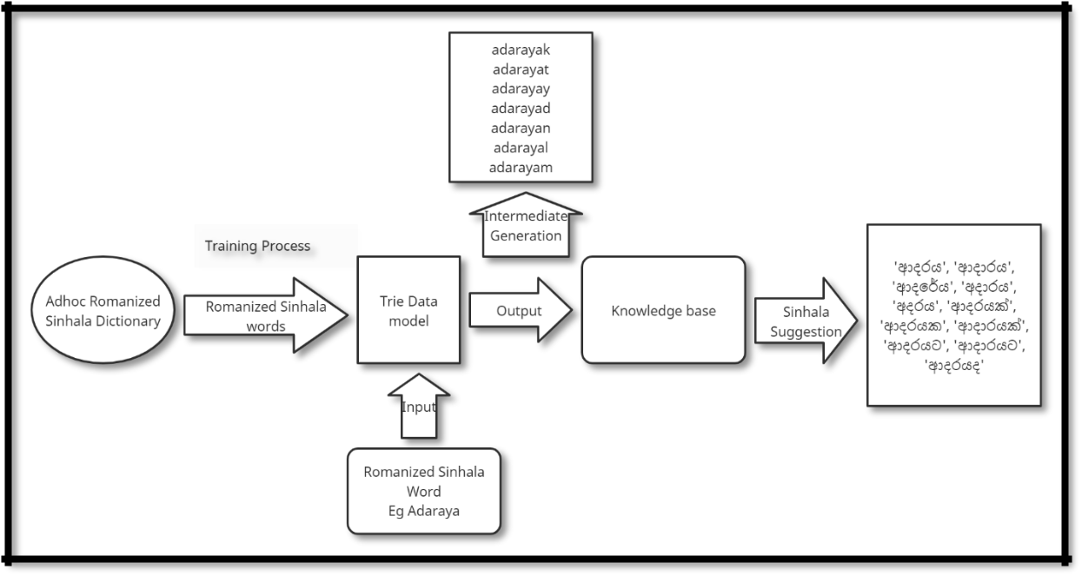

Figure 4.1 Trie Model training

1.6.2 Best Word Suggestion

The trained Trie can return all the Romanized Sinhala word suggestions of a Romanized Sinhala character set. The Suggested words are compared with the knowledge base which contains its Sinhala representation to return the best outcome to the users. The best word suggestion

48
algorithm mainly uses a knowledge-based to return the best outcome. The above diagram discusses the exact data flow of the proposed solution.

def suggestionsRec(self, node, word):

- Method to recursively traverse the trie

- and return a whole word.

if node.last:

sin_indexes = [n for n, x in enumerate(eData) if x == word] for i in sin_indexes:

y = int(i)

if sData[y] not in lstword:

# print(sData[y])

lstword.append(sData[y])

1.7 GUI Implementation

GUI implementation is done using python flask, HTML, CSS, and JavaScript. The main routing file of the program is as follows.

import singlishTag

import BreakData

app= Flask(__name__)

@app.route("/")

def index():

return render_template("index.html")

@app.route('/', methods =["GET", "POST"])

def gfg():

if request.method == "POST":

text = request.form.get("source")

result = singlishTag.triGramTranslate(text)

return render_template("index.html",source=text,result=result)

return render_template("index.html")

@app.route('/suggest', methods =["GET", "POST"])

49
def funsug():

if request.method == "POST":

s=request.form.get("s")

r=request.form.get("r")

text = request.form.get("stext")

result = BreakData.translate(text)

val=""

if result == -1 :

val = "No suggestions"

elif isinstance(result,int):

val = "No suggestions"

else:

for j in result:

val+=j

val+='\n'

return render_template("suggest.html",source=r,result=s,suggest=val)

return render_template("suggest.html")

@app.route('/form', methods =["GET", "POST"])

def form():

if request.method == "POST":

text = request.form.get("source")

result = BreakData.translate(text)

strfinal=""

for i in result:

strfinal+=i

strfinal+=" "

return render_template("form.html",source=text,result=strfinal)

return render_template("form.html")

if __name__ =="__main__":

app.run(host="127.0.0.1", port=8000, debug=True)

50
1.8 GUI

The index page is as follows. The user can insert the Romanized Sinhala sentence into the top section and the button transliterate will generate the expected output in the section Sinhala sentence. By ambiguity solver, the user can request word suggestions as indicated in the Figure 4.3 of the section.
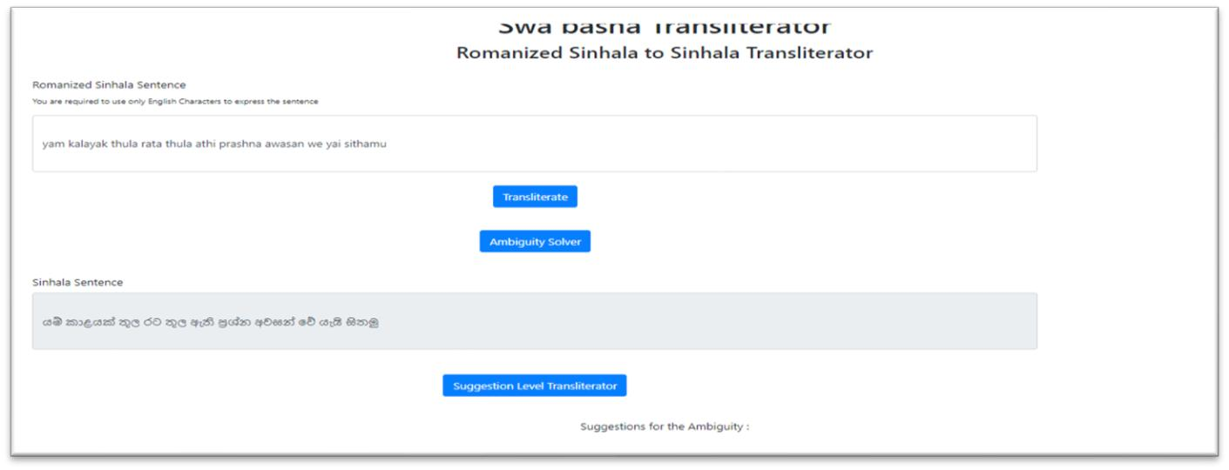

Figure 4.2 GUI for Transliterator home page
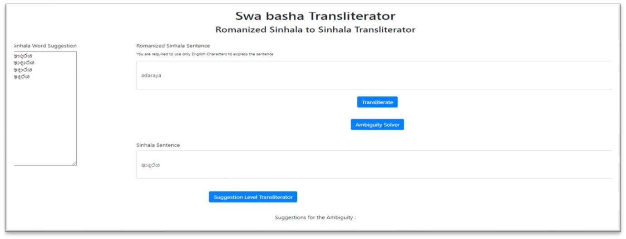

Figure 4.3 GUI for suggestion level Transliterator

1.9 Chapter Summary

In this chapter the implementation of the system, the Technology stack, used algorithms and the UI components are discussed.

51

CHAPTER 5

EVALUATION AND RESULTS

5.1 Chapter Overview

This chapter provides an overview of Quantitative evaluations and Qualitative evaluations based on feedback collected from domain experts, technical experts, academic experts, and researchers for different aspects of the research and prototype, such as the novelty of the concept, quality of the final product etc. The author’s evaluation of different criteria is also to be presented. Functional and non-functional requirements will be evaluated to ensure that system meets the expected requirement.

5.2 Evaluation Methodology and Approach

The Evaluation is to measure the success of a project. Feedback to be collected regarding the research problem, design, implementation, testing and other major phases of a project. The Romanized Sinhala to Sinhala Transliterator is a research project that mainly focuses on proposing a novel architecture for Reverse transliterating. Therefore, the author has chosen qualitative and quantitative approaches to evaluate the success of the project. To analyze the qualitative data, deductive thematic analysis is to be used. Despite the qualitative evaluations, quantitative evaluation feedback will be gathered during the evaluation phase and will be analyzed and presented in the quantitative evaluation chapter. Questionnaires will be distributed, and interviews to be conducted with domain experts to gather feedback. The benchmarking evaluation will be performed against the existing system against different datasets.

52
5.3 Evaluation Criteria

5.3.1 Self-evaluation

Criteria | Authors Evaluation | Discussion
Concept of the | Authors’ view on the | The main aim of the research is to
research | Concept of the research to | build a reverse transliterator for
 | be provided. | Romanized Sinhala to Sinhala which
 |  | can respond to Adhoc transliterals
Scope and depth of | Authors’ view on the | The Scope and the depth have been
the project | Scope and depth of the | discussed under section no one.
 | project to be provided.
System design | Author's view on the | The proposed hybrid architecture
 | System design to be | which is muchly credible to perform
 | provided. | the transliteration process has been
 |  | discussed. Ngram model, Rule based
 |  | with Suggestion level algorithm
 |  | enhanced the accuracy of the system.
Solution and the | Authors’ view on the | The web-based application with user-
prototype | Solution and the prototype | friendly UI has been provided.
 | to be provided. | Prediction and suggestion level
 |  | interfaces provide a better sight to the
 |  | user.
Limitations and | Authors’ view on the | The system is limited to Sinhala
future enhancements | Limitations and future | where code mixed language can be
 | enhancements to be | used in the future to predict the better
 | provided. | output.

5.3.2 Qualitative Evaluation

The following evaluation criteria were defined according to the principles identified for the evaluation. The Qualitative analysis will be performed based on the below criteria and the form uses to collect qualitative feedback is attached in the appendix.

53
Evaluation Criteria

Criteria | Purpose
Concept / Novelty / Difficulty / Scope
The novelty and | To evaluate the novelty of the proposed concept.
concept
The scope of the | To evaluate the project scope by experts.
project
Proposed architecture | The proposed solution architecture was evaluated.
Technical difficulty | Evaluate and get feedback on the technical difficulty.
Design / Architecture / Implementation
Overall Solution | Evaluate whether the system provides a solution to the identified
 | problem
System architecture | Evaluate the system architecture.
Technology stack | Expert feedback on the used technology stack
Limitations | limitations on design
Future work/features | Improvements/ suggestions for the design or architecture.
suggestions
Quality of the GUI | Expert feedback on the GUI quality.

Selection of Evaluators

The selection of evaluators will be based on the following Requirements and Expertise.

Category | Evaluator | Requirement | Expected Expertise
C1 | Domain and Technical | Evaluating Novelty, | • | Experience in the
 | Experts (Area of NLP, | Scope, Architecture, |  | area.
 | Data Science and | Design, and | • | Graduate
 | Machine learning) | implementation.
C2 | Technical Experts | Evaluating the | • | Experience in the
 |  | Technical Stack, |  | area.
 |  | Usability and GUI | • | Graduate
 |  | Components.
 |  | 54
C3 | Beginner Researchers | Evaluating the overall | • | Undergraduate
 |  | Solution and the
 |  | technical limitations.
C4 | General Community | Evaluating the overall | • | Using English –
 |  | solution. |  | Sinhala
 |  |  |  | Keyboards
 |  |  | • | Technical Fluency
 |  |  |  | to use an
 |  |  |  | application

Qualitative Evaluation Results

The below table demonstrates the evaluators' details who evaluated the system.

EID | Position | Affiliation | Academic | Category
1 | Research Head | Orel-IT | PhD | C1, C2
2 | System | Jabil, New York | PhD | C2
 | Engineer and | Florida International University
 | Senior Lecturer
3 | Senior Lecturer | University of Kelaniya | PhD | C1, C2
4 | PhD Candidate | Robert Gordon University | PhD (Reading) | C1, C2
5 | PhD Candidate | University of Westminster | PhD (Reading) | C1, C2
6 | Senior Lecturer | Informatics Institute of | MSc | C1
 |  | Technology
7 | Lecturer | Informatics Institute of | MSc | C1, C2
 |  | Technology
8 | Lecturer | Informatics Institute of | MSc | C1, C2
 |  | Technology
9 | Quality | Matific | MSc (Reading) | C2
 | Assurance
 | Engineer
10 | Research | Edith Cowan University | MSc (Reading) | C2
 | Assistant
11 | Lecturer | Sri Lanka Institute of Information | MSc | C1, C2
 |  | Technology (SLIIT)
12 | Software | Intervest Software Technologies | MSc | C2
 | Engineer
13 | Research | University of Chemistry and | MSc (Reading) | C4
 | Assistant | Technology, Prague
14 | Undergraduate | Informatics Institute of | BSc (Reading) | C3
 | Student | Technology
15 | Undergraduate | Informatics Institute of | BSc (Reading) | C3
 | Student | Technology
16 | Lecturer | Informatics Institute of | BSc | C4
 |  | Technology
 |  | 55

The general feedback by the evaluators are as follows.

EID | Feedback
1 | The candidate has done a reasonable attempt to make transliteration of Romanized Sinhala to
 | Sinhala using a hybrid approach. The ad-hoc transliteration algorithm used in the system has
 | enhanced the experience of the transliteration. System need be integrated with Transliteration
 | frameworks. Overall solution is very Good.
2 | The candidate has put significant effort and time towards the project and developed a usable
 | transliteration tool. Data were acquired in the form of research beforehand. He has considered
 | most of the practical aspects and well-defined the project's scope, and achieved them. The
 | same person may spell the same word in different letters based on their mood, and the
 | candidate | has | considered | that | in | the | development.
 | Great presentation and excellent work.
3 | This Romanized sinhala to sinhala translator is technically an ensemble model containing
 | different algorithms resulting good accuracy. It's usability and practicability is high. Usability
 | is further improved with "Ambiguity Solver" and "Suggestions" and better to make this
 | available as a software/service.
4 | The research appears to be challenging, with the prototype showcasing the end result in
 | converting variations of a Romanized Sinhala word to the corresponding possible Sinhala
 | word or alternatives. The GUI could be improved but it is satisfactory in showing the essence
 | of the research. Could suggest to do more random inputs from social media to get a real-feel
 | of a accuracy rating.
5 | A good research problem and solution indeed. The approach and the methodology are
 | satisfying, and the result is also promising. Hope this would be improved into a pluggable
 | solution to the current systems.
6 | This work is focused on Romanized sinhala to sinhala translation by a novel model that
 | contains a combination of statistical, rule based and a knowledge-based approaches. This has
 | contributed towards improving the accuracy of this type of translations. Also the researchers
 | have considered different types romanizations to improve the practicality of the product. A
 | simple and user friendly UI improves the usability of the application. Overall, from both the
 | technical contribution and practicability point of view, this application this is a very good
 | work.
7 | Ambiguity solver words cannot identify the quickly. try to show those words separate area.
 | This is a good project more than currently existing system. That suggestion words are more
 | effective. Then user can get clear idea about what it is.
8 | The depth of the project is good but try to apply a neural network model to improve the
 | accuracy further.
9 | Transliteration has been taken into the next step through this research project where it can be
 | further improved into a better version in the business perspective.
10 | very good scope
11 | Good attempt in terms of the scope of the research and the usability of the application.
12 | Satisfied with the output demonstrated using the prototype. UI could be further improved.
13 | Excellent work. This would make the work more efficient.
14 | The system architecture, implementation, technologies and tools are all excellent
15 | Accuracy, Fluency, and clarity of the local language are acceptable. Appropriate tone and
 | style are used.
16 | Some Sinhala words do not consider the actual Sinhala grammar. This would be fine if the
 | user is only interested in learning pronunciation but would be a problem if the user is also
 | interested in learning writing as well.

56
5.3.3 Quantitative Evaluation

The Quantitative analysis of this research work describes the credibility of the model and system based on the numerical data. The author of this work will use two quantitative evaluations as follows.

A descriptive analysis of Quantitative data

The quantitative analysis will be carried out according to the below 5 main sections.

The results captured will be analyzed using the descriptive analysis method.

Table 5.1 Evaluation Criteria for Quantitative data in Survey

Criteria | Evaluating Section | Description | Evaluation Criteria
1 | Novelty, scope, technical | Linear scale to be | 0 | -5 scale
 | difficulty | used.
 |  |  | 0 | - poor
2 | System architecture, | Linear scale to be | 0 | - poor
 | implementation, Technologies, | used. | 5 | - Excellent
 | and Tools
3 | Overall solution | Linear scale to be
 |  | used.
4 | Testing, Accuracy of the | Linear scale to be
 | prototype | used.
5 | Overall feedback on the GUI | Linear scale to be
 |  | used.

Quantitative Evaluation Results based on the evaluation.

- 25 evaluators have responded to the evaluation form. The summary of the results is as follows.

- The discussion is based on the criteria given in table 5.1.

Criteria: Novelty, Scope, Technical difficulty Result
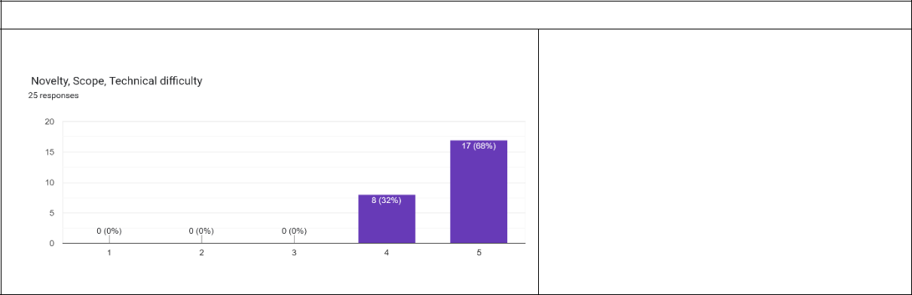

Discussion:

68% of the evaluators say that the novelty, scope and technical difficulty of the project is very high, and 32% percentage agree on the same with stating high.

57

Author’s review: This idea of transliteration using Adhoc transliteration is a novel idea where currently any existing systems are not capable to transliterate using vowel-free typing.

Criteria: System architecture, Implementation, Technologies, and Tools
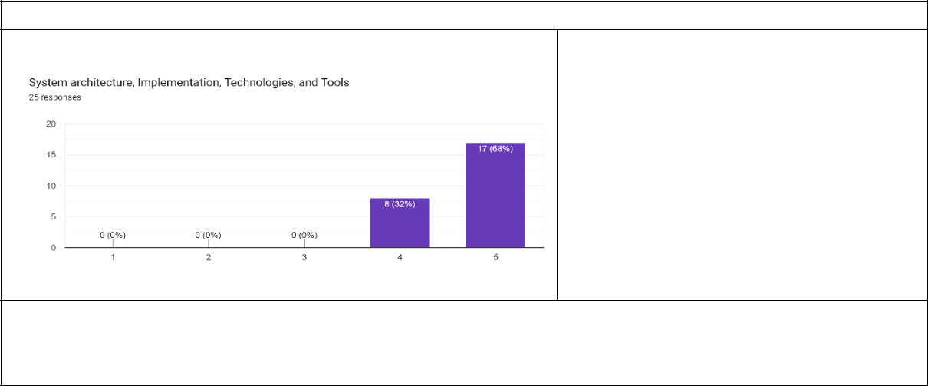

Result Discussion

68% of the evaluators say that the System architecture, Implementation, Technologies, and Tools of the project is highly appropriate and relevant, and the rest 32% percentage agree on the same.

Author’s review: The system uses ngram, rule and knowledge based approaches together to perform the transliteration. The hybrid model has done justice to the Romanized Sinhala to Sinhala Transliteration.

Criteria: Overall Solution
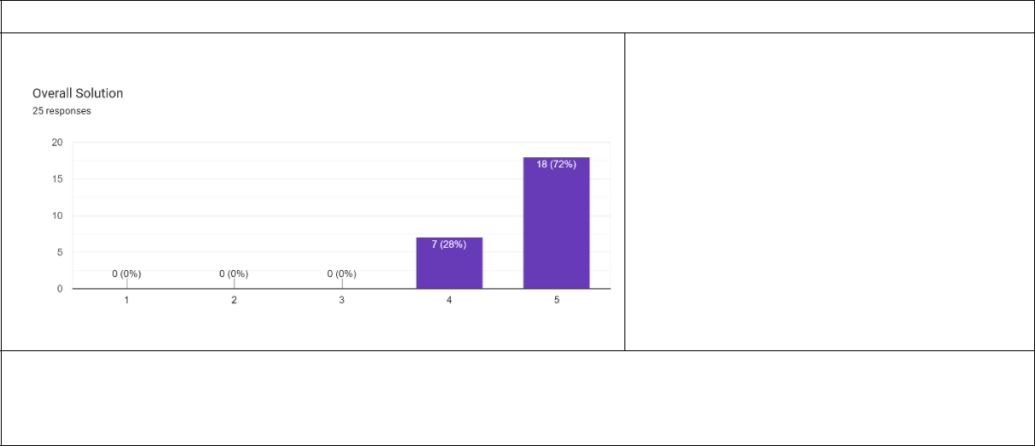

Result Discussion

72% of the evaluators say that the Overall Solution of the project is highly appropriate and can be pluggable into the current system, and the rest 28% percentage agree on the same with a rating as 4.

Author’s review: The overall proposed solution is capable of Transliterating Romanized Sinhala to Sinhala. Adhoc Transliterals are taken into consideration when personalized typing is captured through the work.

Criteria: Accuracy in Transliteration and Usability the of Prototype
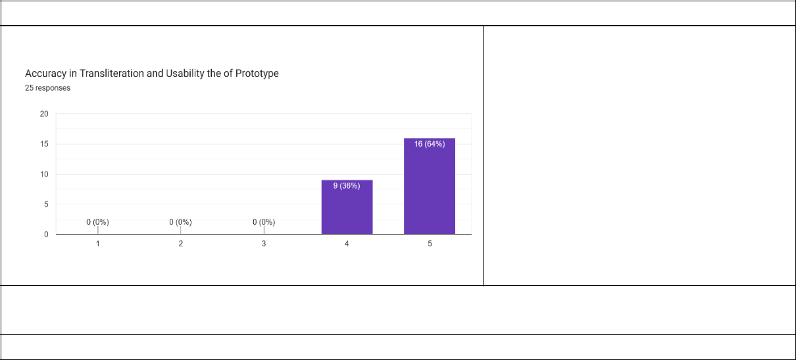

Result Discussion

64% of the evaluators say that the Accuracy of the transliteration of the project is excellent while rest 36% percentage agree on the same with rating as 4.

Author’s review: The system accuracy is 84% in the suggestion level. The system's accuracy can be enhanced by using more data to train the model.
Criteria: GUI of the prototype

58

Result
Discussion
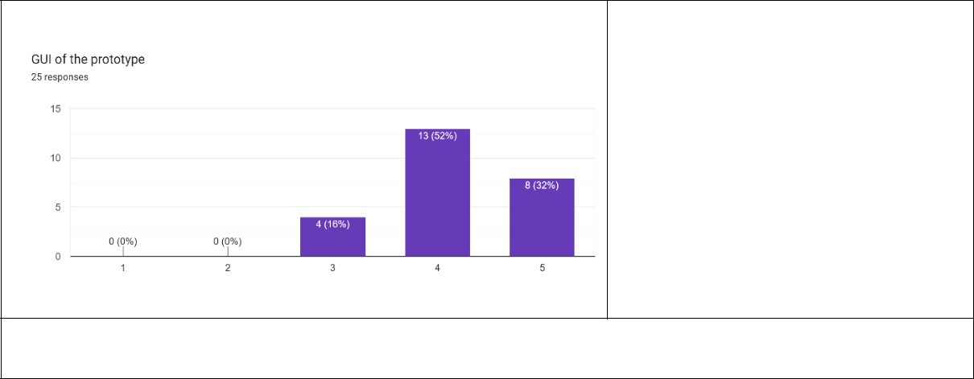

32% of the evaluators say that the GUI component of the project is excellent and rest 52% agree with the status as good. 16% say its moderate.

Author’s review: The GUI need to be enhanced to improve the user-friendliness. The system can be implemented such that it can be a pluggable module to all the current system

5.3.4 Numerical Analysis

BLEU (Bilingual Evaluation Understudy) is a metric for automatically evaluating

machine-translated text. The BLEU score is a number between zero (0) and one (1) that

measures the similarity of the machine-translated text to a set of high-quality reference

translations. (Osborne and Koehn, 2006) The proposed system will be evaluated with the below

datasets to generate the BLEU score.

The Dataset | Reference
Hate Speech Dataset for Romanized | (Liwera and Ranathunga, 2020)
Sinhala by Liwera.
Results

The corpus_bleu of NLTK was used to identify the result. The following Bleu matrixes were used.

print('BLEU-1: %f' % corpus_bleu(a, p, weights=(1.0, 0, 0, 0)))

print('BLEU-2: %f' % corpus_bleu(a, p, weights=(0.5, 0.5, 0, 0)))
print('BLEU-3: %f' % corpus_bleu(a, p, weights=(0.3, 0.3, 0.3, 0)))
print('BLEU-4: %f' % corpus_bleu(a, p, weights=(0.25, 0.25, 0.25, 0.25)))

The Results are as follows.

BLEU |  | Score
BLEU-1 |  | 0.820000
BLEU-2 |  | 0.804462
BLEU-3 |  | 0.777854
BLEU-4 |  | 0.711657
 | 59

Furthermore different systems available in the literature, and commercial products will be evaluated based on the test data of the Dakshina dataset. (Roark et al., 2020). The word level Accuracy is to be measured using the accuracy score based on the below criteria.

Criteria |  | Dataset to be used
Word Level | Predicting level | Dakshina Dataset
Accuracy |  | (Roark et al., 2020)
 | Suggestion level | Dakshina Dataset
 |  | ((Roark et al., 2020)

The benchmark of the system compared to the current literature are as follows. The models were tested with 200 unique data records. 100 data record was randomly selected from liwera’s (Liwera and Ranathunga, 2020) dataset, which was much towards the general Sinhala words for communication and 100 unique data tuples were taken from the Dakshina dataset which is from the documentation. The sentences were fed to the model and word-based suggestion from the Trie model was evaluated.

The accuracy was generated using the below equations:

Accuracy = (Correctly suggested words / Total words) * 100%

Results

Transliterator |  |  | Technology Used | Accuracy (word Level)
(Liwera | and | Ranathunga, | N gram + rule-based | 0.62
2020) |  |  | Algorithm
(Athukorala |  | and | Rule based and Fuzzy logic | 0.74
Sumanathilaka, 2021)
Proposed | Novel Swabasha |  | Ngram + Rule base and | 0.84
Transliterator |  |  | Trie with a knowledge base

5.3.5 Evaluation of Functional Requirements.

The functional and non-functional requirements are to be evaluated based on the below

criteria.

60
FRID | Requirement ID | Priority Level | Status
FR1 | The user should be able to type | Highly Important | Completed.
 | Romanized Sinhala words via the
 | keyboard as input.
FR2 | The system should generate the | Highly Important | Completed.
 | native Sinhala words by considering
 | the entered Romanized Sinhala
 | words.
FR3 | The system should predict and | Highly Important | Completed.
 | suggest appropriate Sinhala word
 | and display it to the user.
FR4 | The system should be able to use the | Important | Completed.
 | predicted word for the output.
 | Functional Requirement completion | rate | 100%

5.3.6 Evaluation of the Research Questions

- RQ1: How to create a valid dataset to perform back transliteration.

The dataset creation has been conducted based on the rule identified through the survey which has been done over the general community. The typing patterns were identified and build an algorithm to generate all the typing possibilities.

- RQ2: How to identify the Sinhala words and their typing patterns which are frequently used by people when texting.
The Social media data has been extracted using an open-source tool called face pager and the data was analyzed to identify the typing patterns.

- RQ3: How to build the optimal algorithm to back-transliterate Romanized Sinhala to Sinhala.
A hybrid algorithm which contains an n-gram model, Rule-based and Knowledge-based has been used to perform the back-transliteration process. The algorithm will be evaluated with multiple datasets for its performance. Benchmarking will be performed concerning the existing products.

61
- RQ4: What kind of preprocessing steps and learning methods should be carried out for the core component.
Multiple NLP-based preprocessing steps have been used to perform the preprocessing of the data required to be fed to the model. Detailed information has been provided in the methodology chapter.

5.4 Benchmarking the functionalities

Criteria | Swabasha | (Liwera and | (Silva and | Helakuru
 | Transliterator | Ranathunga, | Ahangama, | (Bhasha,
 | (Proposed | 2020) | 2021) | 2011)
 | Solution)
Transliteration | of
Romanized Sinhala to
Sinhala.
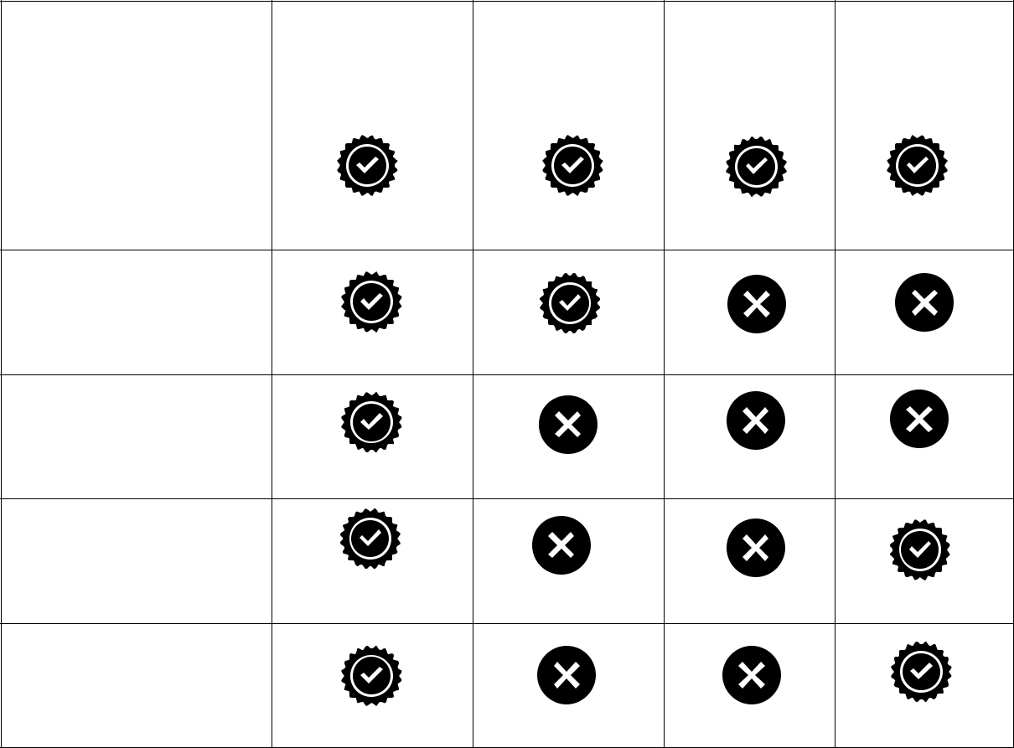

Short typing (Adhoc

Transliteration) for
Transliteration

Word Suggestion for

ambiguity-based
words.

Web application for

the tool.

Next characters

suggestion for
Romanized Sinhala
based on input.

5.5 Chapter Summary

This chapter focused on evaluating the model using Quantitative and Qualitative techniques. A detailed evaluation plan is discussed in the above chapter.

62
CHAPTER 6

CONCLUSION AND FUTURE WORKS

6.1 Chapter overview

This chapter presents the project's final remarks. It was analyzed whether the project aims, and objectives were met successfully, the challenges encountered and the limitation with future works. The research contributions to the domain and computer science are presented.

6.2 Conclusion

In a conclusion, the proposed novel transliterator can Reverse transliterate the Romanized Sinhala to Sinhala which is written using shorthand typing. The aim of the project which is to analyze, design, develop and evaluate a generalized system that back transliterates Romanized Sinhala to Sinhala using word level N-gram and rule-based module with handling ambiguity in the transliteration process by suggestion algorithm using a Trie has been successfully achieved.

And Adhoc Romanized Sinhala to Sinhala Dataset has been created using a novel algorithm based on the survey data. This novel transliterator which uses a hybrid approach can escalate the Native language usage among Sri Lankans on digital platforms.

6.3 Limitations of the Research

- Code mixed Romanized Sinhala is not considered in the project.

- The annotation algorithm can be enhanced by analyzing the survey data.

- Special characters are not handled by transliterators.

63
6.4 Future work of the Research

6.4.1 Research Components

- The Neural-based approach which uses the seq2seq model can cooperate with the model.

- The code-mixed language which uses both Romanized Sinhala and English can cooperate with the algorithm.

- A general framework for extracting the rules from the survey data can be introduced.

- Short-net acronyms can be introduced with the system.

- The proposed architecture can be tested with south Indian languages.

6.4.2 Product Component

- The system can be made available as a keyboard to the mobile application, such that users can use the software as a 3rd party application to type Sinhala.
- The mobile compatibility of the web tool can be enhanced.

6.5 Chapter Summary

This chapter discussed the conclusion, limitations and future works that can be cooperated in the project.

64
REFERENCES

De Silva, D. et al. (2008) ‘Sinhala to English Language Translator’, in 2008 4th International Conference on Information and Automation for Sustainability. 2008 4th International Conference on Information and Automation for Sustainability (ICIAFS), Colombo, Sri Lanka: IEEE, pp. 419–

- doi:10.1109/ICIAFS.2008.4783983.Athukorala, M.U., Sumanathilaka, D.K., 2021. Swa Bhasha: Message-Based Singlish to Sinhala Transliteration. Int. Conf. Innov. Info-Bus. Technol. ICIIT2022 Inform. Inst. Technol. Colombo 006 Sri Lanka 6.
Bhasha, D.P., 2011. Helakuru Transliterator.
de Silva, N., 2021. Survey on Publicly Available Sinhala Natural Language Processing Tools and Research. ArXiv190602358 Cs.
Hettiarachchi, N., Weerasinghe, R., Pushpanda, R., 2020. Detecting Hate Speech in Social Media Articles in Romanized Sinhala, in: 2020 20th International Conference on Advances in ICT for Emerging Regions (ICTer). Presented at the 2020 20th International Conference on Advances in ICT for Emerging Regions (ICTer), IEEE, Colombo, Sri Lanka, pp. 250–255. https://doi.org/10.1109/ICTer51097.2020.9325465
Jakob Jünger, T.K., 2014. Facepager 3.6.
Joshi, A., Mehta, K., Gupta, N., Valloli, V.K., 2018. Indian Language Transliteration Using Deep Learning, in: 2018 IEEE Recent Advances in Intelligent Computational Systems (RAICS). Presented at the 2018 IEEE Recent Advances in Intelligent Computational Systems (RAICS), IEEE, Thiruvananthapuram, India, pp. 103–107. https://doi.org/10.1109/RAICS.2018.8635077

Liwera, W.M.P., Ranathunga, L., 2020. Combination of Trigram and Rule-based Model for Singlish to Sinhala Transliteration by Focusing Social Media Text, in: 2020 From Innovation to Impact (FITI). Presented at the 2020 From Innovation to Impact (FITI), IEEE, Colombo, Sri Lanka, pp.

1–5. https://doi.org/10.1109/FITI52050.2020.9424880
Nair, J., Krishnan, K.A., Deetha, R., 2016. An efficient English to Hindi machine translation system using hybrid mechanism, in: 2016 International Conference on Advances in Computing, Communications and Informatics (ICACCI). Presented at the 2016 International Conference on Advances in Computing, Communications and Informatics (ICACCI), IEEE, Jaipur, India, pp. 2109–2113. https://doi.org/10.1109/ICACCI.2016.7732363
Osborne, C.C.-B.M., Koehn, P., 2006. Re-evaluating the Role of BLEU in Machine Translation Research 8.
Roark, B., Wolf-Sonkin, L., Kirov, C., Mielke, S.J., Johny, C., Demirsahin, I., Hall, K., 2020. Processing South Asian Languages Written in the Latin Script: the Dakshina Dataset 11.
Sandaruwan, D., Sumathipala, S., Fernando, S., 2021. Neural Machine Translation Approach for Singlish to English Translation. Int. J. Adv. ICT Emerg. Reg. ICTer 14, 36. https://doi.org/10.4038/icter.v14i3.7230
Silva, L. de, Ahangama, S., 2021. Singlish to Sinhala Transliteration using Rule-based Approach, in:
2021 IEEE 16th International Conference on Industrial and Information Systems (ICIIS).
Presented at the 2021 IEEE 16th International Conference on Industrial and Information Systems
(ICIIS), IEEE, Kandy, Sri Lanka, pp. 162–167.
https://doi.org/10.1109/ICIIS53135.2021.9660744
Vidanaralage, A.J., Illangakoon, A.U., Sumanaweera, S.Y., Pavithra, C., Thelijjagoda, S., 2018. Sinhala Language Decoder, in: 2018 National Information Technology Conference (NITC). Presented at the 2018 National Information Technology Conference (NITC), IEEE, Colombo, pp. 1–5. https://doi.org/10.1109/NITC.2018.8550074

Wijerathna, L., Somaweera, W.L.S.L., Kaduruwana, S.L., Wijesinghe, Y.V., De Silva, D.I., Pulasinghe, K., Thellijjagoda, S., 2012. A Translator from Sinhala to English and English to Sinhala (SEES), in: International Conference on Advances in ICT for Emerging Regions (ICTer2012). Presented at the 2012 International Conference on Advances in ICT for Emerging Regions (ICTer), IEEE, Colombo, Western, Sri Lanka, pp. 14–18. https://doi.org/10.1109/ICTer.2012.6421408

I
Dhariya, O., Malviya, S. and Tiwary, U.S. (2017) ‘A hybrid approach for Hindi-English machine translation’, in 2017 International Conference on Information Networking (ICOIN). 2017 International Conference on Information Networking (ICOIN), Da Nang, Vietnam: IEEE, pp.

389–394. doi:10.1109/ICOIN.2017.7899465.
Hettiarachchi, N., Weerasinghe, R. and Pushpanda, R. (2020) ‘Detecting Hate Speech in Social Media Articles in Romanized Sinhala’, in 2020 20th International Conference on Advances in ICT for Emerging Regions (ICTer). 2020 20th International Conference on Advances in ICT for Emerging Regions (ICTer), Colombo, Sri Lanka: IEEE, pp. 250–255. doi:10.1109/ICTer51097.2020.9325465.

Joshi, A. et al. (2018) ‘Indian Language Transliteration Using Deep Learning’, in 2018 IEEE Recent Advances in Intelligent Computational Systems (RAICS). 2018 IEEE Recent Advances in Intelligent Computational Systems (RAICS), Thiruvananthapuram, India: IEEE, pp. 103–107. doi:10.1109/RAICS.2018.8635077.
Liwera, W.M.P. and Ranathunga, L. (2020) ‘Combination of Trigram and Rule-based Model for Singlish to Sinhala Transliteration by Focusing Social Media Text’, in 2020 From Innovation to Impact (FITI). 2020 From Innovation to Impact (FITI), Colombo, Sri Lanka: IEEE, pp. 1–5. doi:10.1109/FITI52050.2020.9424880.
Nair, J., Krishnan, K.A. and Deetha, R. (2016) ‘An efficient English to Hindi machine translation system using hybrid mechanism’, in 2016 International Conference on Advances in Computing, Communications and Informatics (ICACCI). 2016 International Conference on Advances in Computing, Communications and Informatics (ICACCI), Jaipur, India: IEEE, pp. 2109–2113. doi:10.1109/ICACCI.2016.7732363.

P.J., A., V.P., A. and K.P., S. (2010) ‘Kernel Method for English to Kannada Transliteration’, in 2010 International Conference on Recent Trends in Information, Telecommunication and Computing. 2010 International Conference on Recent Trends in Information, Telecommunication and Computing (ITC 2010), Kochi, Kerala: IEEE, pp. 336–338. doi:10.1109/ITC.2010.85.

Ranathunga, S. et al. (2018) ‘Si-Ta: Machine Translation of Sinhala and Tamil Official Documents’, in 2018 National Information Technology Conference (NITC). 2018 National Information Technology Conference (NITC), Colombo: IEEE, pp. 1–6. doi:10.1109/NITC.2018.8550069.
Sandaruwan, D., Sumathipala, S. and Fernando, S. (2021) ‘Neural Machine Translation Approach for Singlish to English Translation’, International Journal on Advances in ICT for Emerging Regions (ICTer), 14(3), p. 36. doi:10.4038/icter.v14i3.7230.
de Silva, N. (2021) ‘Survey on Publicly Available Sinhala Natural Language Processing Tools and Research’, arXiv:1906.02358 [cs] [Preprint]. Available at: http://arxiv.org/abs/1906.02358 (Accessed: 13 July 2021).
Vidanaralage, A.J. et al. (2018) ‘Sinhala Language Decoder’, in 2018 National Information Technology Conference (NITC). 2018 National Information Technology Conference (NITC), Colombo: IEEE, pp. 1–5. doi:10.1109/NITC.2018.8550074.
Wijerathna, L. et al. (2012) ‘A Translator from Sinhala to English and English to Sinhala (SEES)’, in International Conference on Advances in ICT for Emerging Regions (ICTer2012). 2012 International Conference on Advances in ICT for Emerging Regions (ICTer), Colombo, Western, Sri Lanka: IEEE, pp. 14–18. doi:10.1109/ICTer.2012.6421408

II
Appendix

- Form to collect the Romanized Sinhala \ Sinhala Transliterals
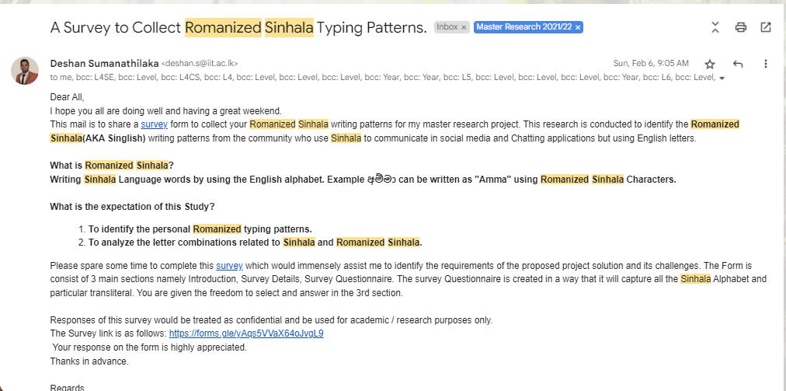

- Final form shared among the selected group
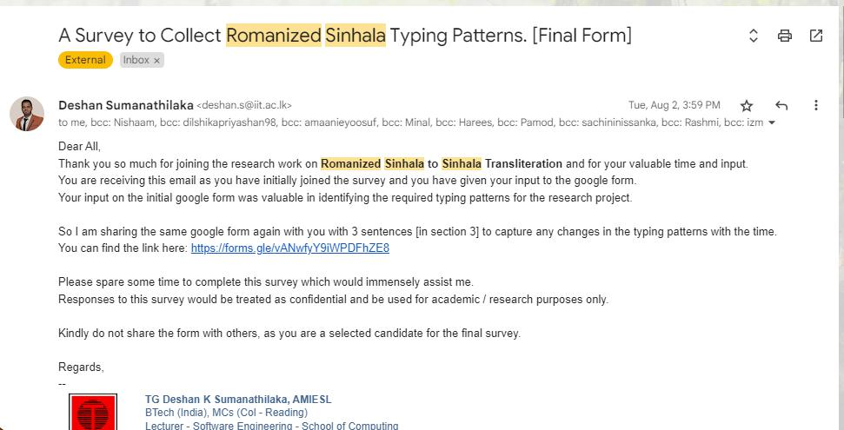

- Google form shared with the community

III
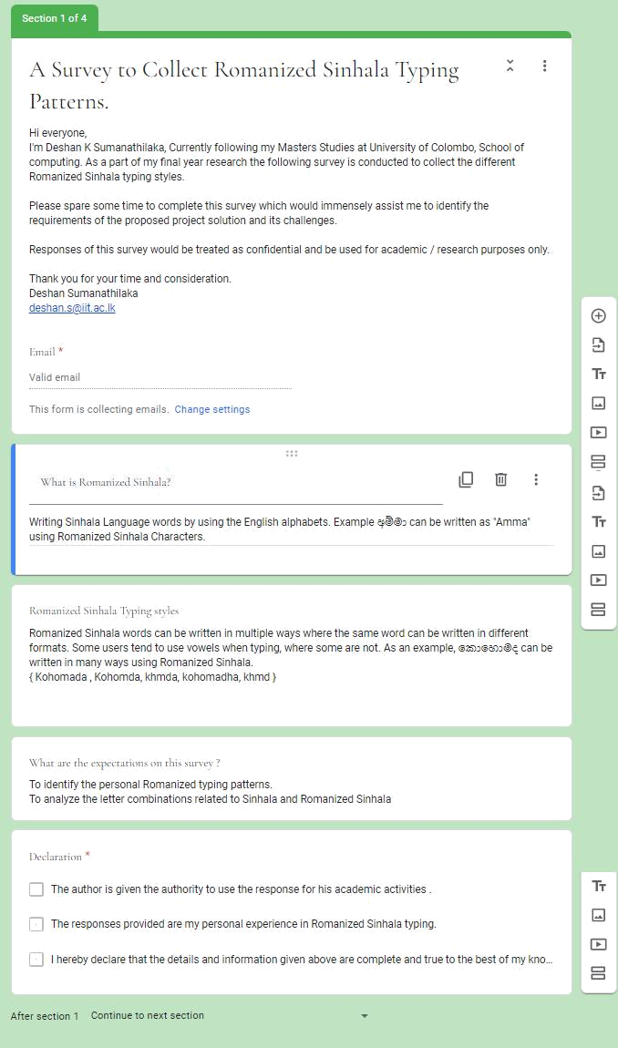

IV
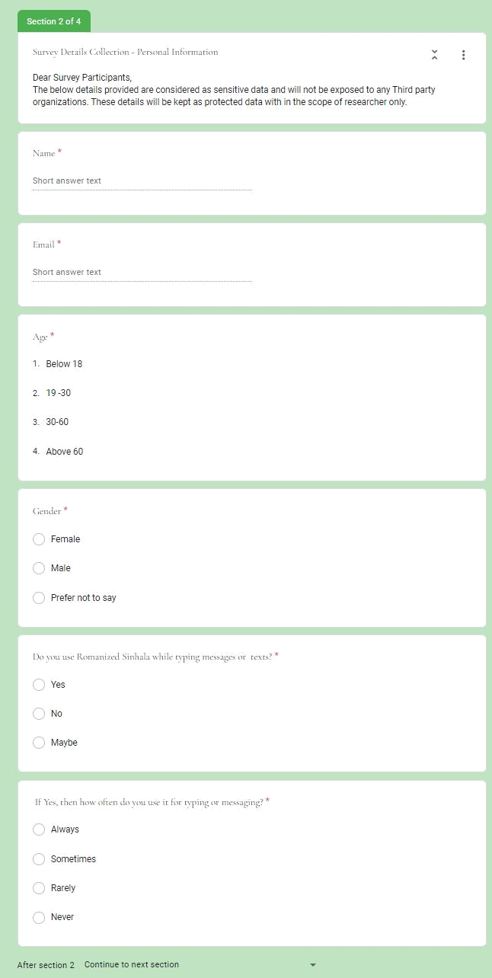

V
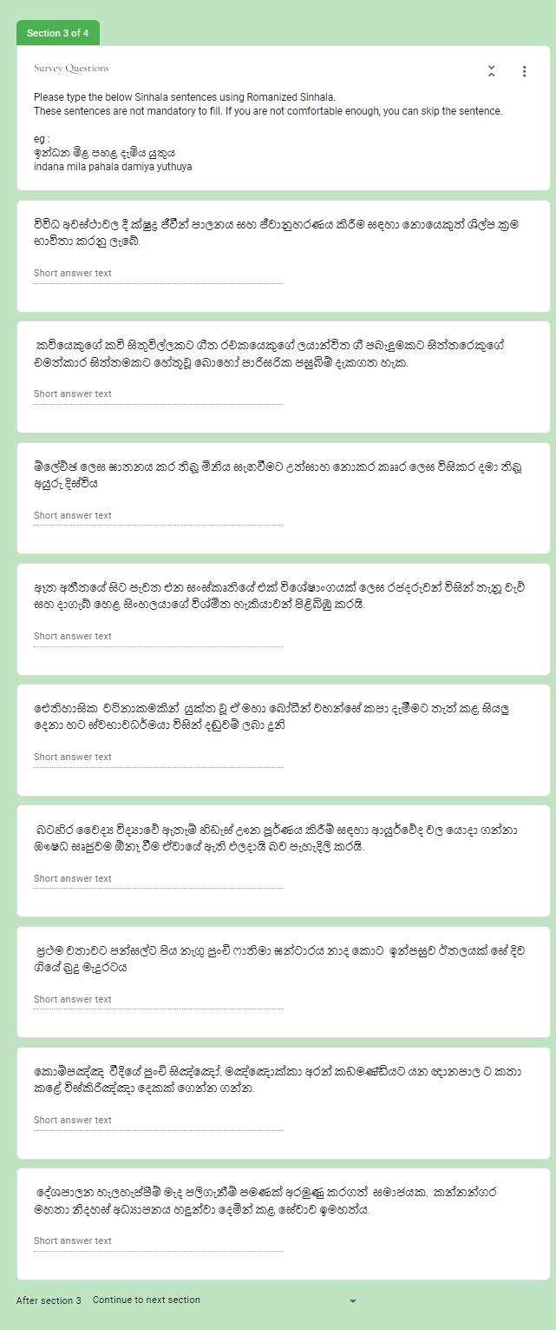

VI
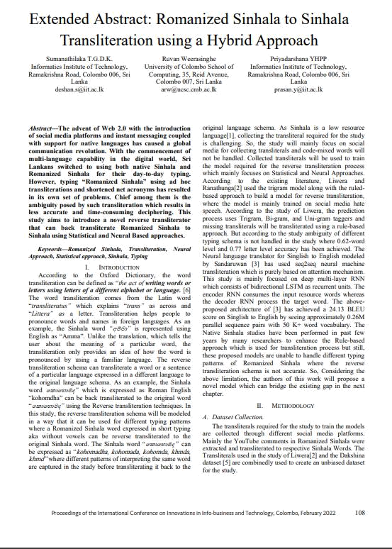

VII
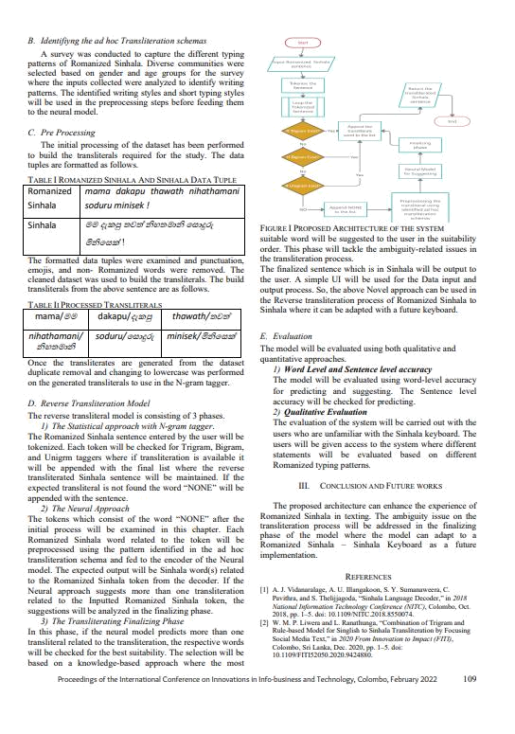

₅th

VIII

5th Student and staff research Conference 2022:

https://sites.google.com/my.westminster.ac.uk/ssrc2022/home
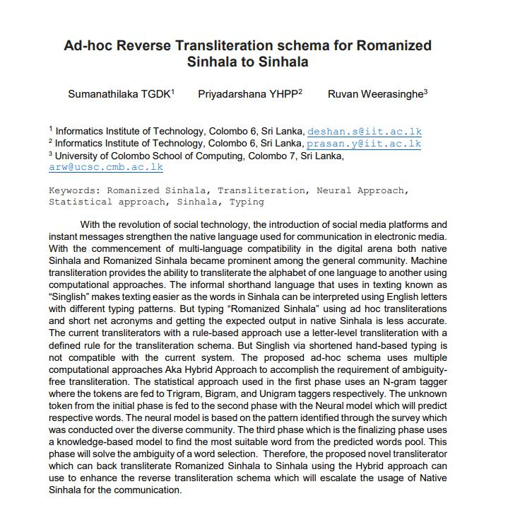

IX
ICIET – 2022 : http://iciet.sjp.ac.lk/
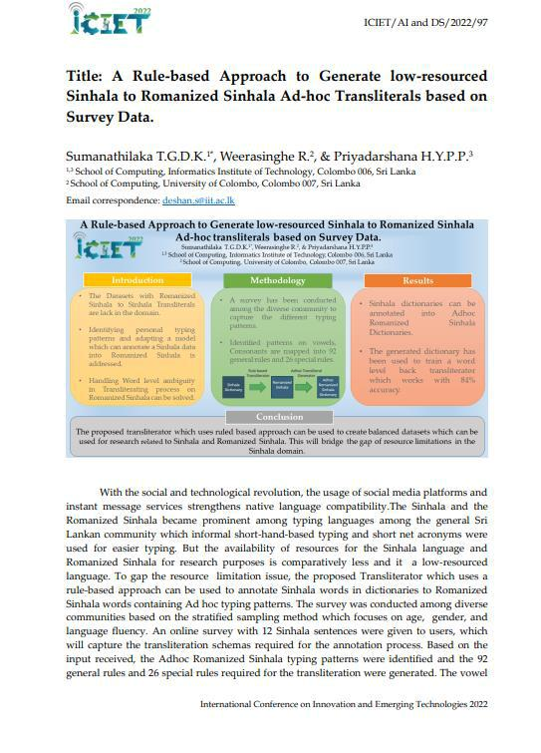

X
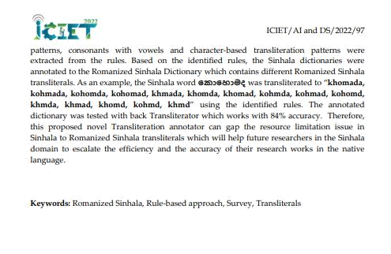

XI
RISTCON 2023 : https://www.sci.ruh.ac.lk/conference/ristcon2023/

Sinhala word suggestion algorithm for Adhoc Sinhala Transliterals using a Trie.
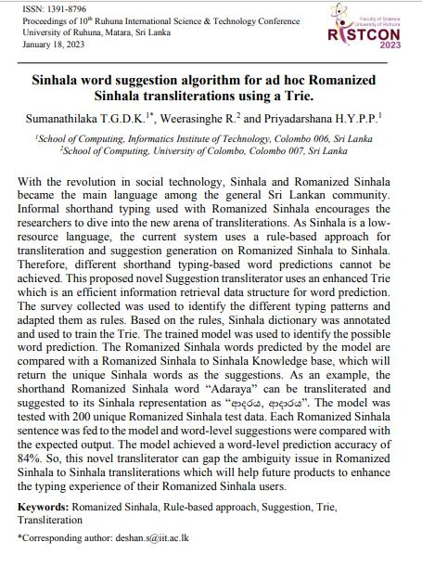

XII
Swa-Bhasha: Romanized Sinhala to Sinhala Reverse Transliteration using a Hybrid Approach

T.G.D.K. Sumanathilaka | Ruvan Weerasinghe | Y.H.P.P. Priyadarshana
T.G.D.K. Sumanathilaka | School of Computing, | School of Computing,
School of Computing, | School of Computing, | School of Computing,
School of Computing, | University of Colombo | Informatics Institute of Technology
Informatics Institute of Technology | University of Colombo | Informatics Institute of Technology
Informatics Institute of Technology | Colombo 007, Sri Lanka | Colombo 006, Sri Lanka
Colombo 006, Sri Lanka | Colombo 007, Sri Lanka | Colombo 006, Sri Lanka
Colombo 006, Sri Lanka | arw@ucsc.cmb.ac.lk | toprasanyapa@gmail.com
deshankoshala@gmail.com | arw@ucsc.cmb.ac.lk | toprasanyapa@gmail.com

Abstract— With the social and technological revolution, the usage of social media platforms and instant message services strengthens native language compatibility in the digital arena. The Sinhala and the Romanized Sinhala became the prominent typing languages among the general Sri Lankan community. Informal short-hand-based typing and short net acronyms were used for easier Sinhala typing. But Typing Romanized Sinhala using ad-hoc transliterations and getting the expected output in native Sinhala is less accurate and time-consuming. Therefore, this study aims to introduce a novel reverse transliterator which can back transliterate and suggest Romanized Sinhala to Sinhala words. The Transliterator has been modelled using the Statistical approach with Trigram and Rule-based model for back transliteration purposes and Knowledge-based with a Trie data structure for suggesting purposes. The proposed solution is capable of transliterating both formal and informal shorthand Romanized Sinhala. This hybrid model used in the study is capable of efficient transliteration with the word level accuracy of 0.84. This proposed model can be used in digital platforms to enhance the usability of native Sinhala communication in a much more efficient way.

Keywords—Romanized Sinhala, Transliteration, Tri-gram, Rule-based, Prediction, Suggestion

Introduction

According to the Oxford Dictionary, the word transliteration [1] means “the act of writing words or letters using letters of a different alphabet or language. The word transliteration comes from the Latin word “transliteratus” which explains “trans” as across and “Littera” as a letter. The transliterations help non-native speakers to pronounce a native word by its Transliteration. As an example, the Sinhala word “අම්ො” is represented using English (Latin) as “Amma”. Unlike translation, which tells the user about the meaning of a particular word, the transliteration only provides an idea of how the word is pronounced by using a familiar language. The reverse transliteration schema can transliterate a word, or a sentence of a particular language expressed in a different language to the original language schema[2]. As an example, the Sinhala word “වකාවහාෙද” which expressed as Roman English “kohomda” can be back transliterated to the original word “වකාවහාෙද” using the Reverse transliteration techniques. In this study, the reverse transliteration schema will be modelled in a way that it can be used for different typing patterns where a Romanized Sinhala word expressed in short typing aka without vowels can be reverse transliterated to the original Sinhala word. The

Sinhala word “වකාවහාෙද” can be expressed as “kohomada, kohomada, kohomda, khmda, khmd” where different patterns of interpreting the same word are captured in the study before transliterating it back to the original language schema. As Sinhala is a low resource language [3], collecting the transliteral required for the study is challenging. So, the study was mainly focused on the publicly available dataset and social media comments for collecting transliterals. The different typing patterns were captured through the online survey and the results were analyzed to identify the different transliterations schemas. Collected transliterals were used to train the hybrid model required for the reverse transliteration process which mainly focused on statistical, Rule based and knowledge base. The Trie structure, a well-known architecture for efficient information retrieval has been used with the knowledge base to perform the suggestion-level Transliteration to handle the ambiguity in the transliteration process.

Related Works

Many countries have adapted machine translation algorithms to their languages. Many of the translation and transliteration processes have taken place in the literature due to the language barrier between native speakers and non-native speakers. The below section will discuss the Sinhala-based machine Translation and non-Sinhala translation techniques.

Rule-based Approach

This is a common machine translation approach used in machine transliteration. The main base of this approach is to implement a system under well-defined rules that are related to the source language and the related language. This approach can be classified based on three schemas namely Direct machine transliteration, transfer based and interlingual Machine translation. Currently, many commercial …………….

XIII

Evaluation form:
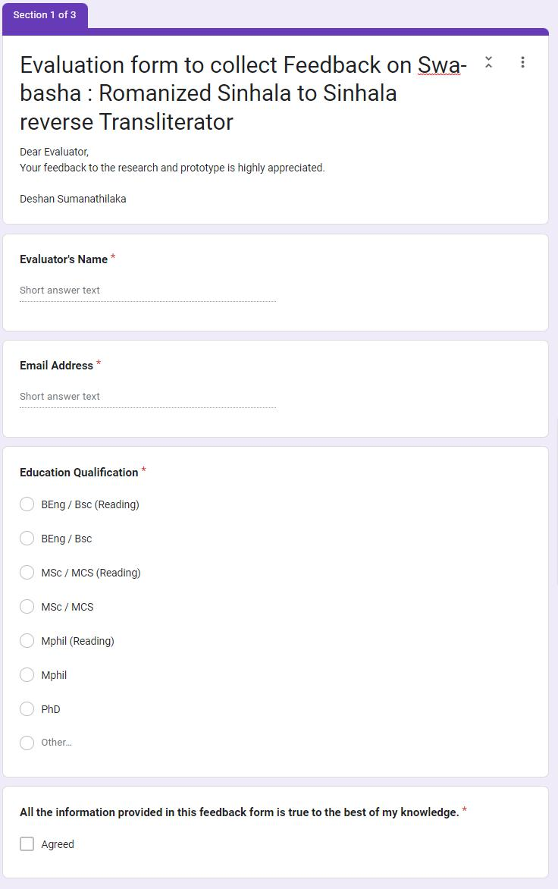

XIV
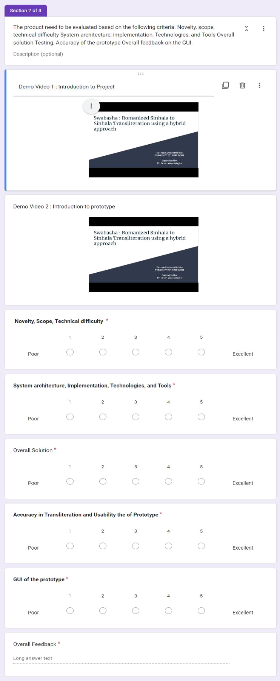

XV

- Rule based rule

def initializeVar():

vowelsUni.append("ඌ")

vowels.append("oo")

vowelModifiersUni.append("ූ")

vowelsUni.append("ඕ")

vowels.append("o\\)")

vowelModifiersUni.append("ෝූ ")

vowelsUni.append("ඕ")

vowels.append("oe")

vowelModifiersUni.append("ෝූ ")

vowelsUni.append("ආ")

vowels.append("aa")

vowelModifiersUni.append("ූ")

vowelsUni.append("ආ")

vowels.append("a\\)")

vowelModifiersUni.append("ූ")

vowelsUni.append("ඈ")

vowels.append("Aa")

vowelModifiersUni.append("ූ")

vowelsUni.append("ඈ")

vowels.append("A\\)")

vowelModifiersUni.append("ූ")

vowelsUni.append("ඈ")

vowels.append("ae")

vowelModifiersUni.append("ූ")

vowelsUni.append("ඊ")

vowels.append("ii")

vowelModifiersUni.append("ූ")

vowelsUni.append("ඊ")

vowels.append("i\\)")

vowelModifiersUni.append("ූ")

vowelsUni.append("ඊ")

vowels.append("ie")

vowelModifiersUni.append("ූ")

vowelsUni.append("ඊ")

vowels.append("ee")

vowelModifiersUni.append("ූ")

vowelsUni.append("ඒ")

vowels.append("ea")
vowelModifiersUni.append("ෝූ ")

vowelsUni.append("ඒ")

vowels.append("e\\)")

vowelModifiersUni.append("ෝූ ")

vowelsUni.append("ඒ")

vowels.append("ei")

vowelModifiersUni.append("ෝූ ")

vowelsUni.append("ඌ")

vowels.append("uu")

vowelModifiersUni.append("ූ")

vowelsUni.append("ඌ")

vowels.append("u\\)")

vowelModifiersUni.append("ූ")

vowelsUni.append("ඖ")

vowels.append("au")

vowelModifiersUni.append("ෝූ ")

vowelsUni.append("ඇ")

vowels.append("\\a")

vowelModifiersUni.append("ූ")

vowelsUni.append("අ")

vowels.append("a")

vowelModifiersUni.append("")

vowelsUni.append("ඇ")

vowels.append("A")

vowelModifiersUni.append("ූ")

vowelsUni.append("ඉ")

vowels.append("i")

vowelModifiersUni.append("ූ")

vowelsUni.append("එ")

vowels.append("e")

vowelModifiersUni.append("ෝූ")

vowelsUni.append("උ")

vowels.append("u")

vowelModifiersUni.append("ූ")

vowelsUni.append("ඔ")

vowels.append("o")

vowelModifiersUni.append("ෝූ ")

vowelsUni.append("ඓ")

vowels.append("I")

vowelModifiersUni.append("ෛූ")

specialConsonantsUni.append("ූ ")

specialConsonants.append("\\n")

XVI
specialConsonantsUni.append("ූ ")

specialConsonants.append("\\h")

specialConsonantsUni.append("ඞ")

specialConsonants.append("\\N")

specialConsonantsUni.append("ඍ")

specialConsonants.append("\\R")

# special character Repaya

specialConsonantsUni.append("ර්")

specialConsonants.append("R")

specialConsonantsUni.append("ර්")

specialConsonants.append("\\r")

consonantsUni.append("ඬ")

consonants.append("nnd")

consonantsUni.append("ඳ")

consonants.append("nndh")

consonantsUni.append("ඟ")

consonants.append("nng")

consonantsUni.append("ත")

consonants.append("th")

consonantsUni.append("ධ")

consonants.append("dh")

consonantsUni.append("ඝ")

consonants.append("gh")

consonantsUni.append("ච")

consonants.append("ch")

consonantsUni.append("ඵ")

consonants.append("ph")

consonantsUni.append("භ")

consonants.append("bh")

consonantsUni.append("ඣ")

consonants.append("jh")

consonantsUni.append("ෂ")

consonants.append("sh")

consonantsUni.append("ඥ")

consonants.append("GN")

consonantsUni.append("ඤ")

consonants.append("KN")

consonantsUni.append("ළු")

consonants.append("Lu")

consonantsUni.append("ඛ")

consonants.append("kh")

consonantsUni.append("ඨ")

consonants.append("Th")

XVII
consonantsUni.append("ඪ")

consonants.append("Dh")

consonantsUni.append("ශ")

consonants.append("S")

consonantsUni.append("ද")

consonants.append("d")

consonantsUni.append("ච")

consonants.append("c")

consonantsUni.append("ත")

consonants.append("th")

consonantsUni.append("ට")

consonants.append("t")

consonantsUni.append("ක")

consonants.append("k")

consonantsUni.append("ඩ")

consonants.append("D")

consonantsUni.append("න")

consonants.append("n")

consonantsUni.append("ප")

consonants.append("p")

consonantsUni.append("බ")

consonants.append("b")

consonantsUni.append("ම")

consonants.append("m")

consonantsUni.append("ය")

consonants.append("Y")

consonantsUni.append("ය")

consonants.append("y")

consonantsUni.append("ජ")

consonants.append("j")

consonantsUni.append("ල")

consonants.append("l")

consonantsUni.append("ව")

consonants.append("v")

consonantsUni.append("ව")

consonants.append("w")

consonantsUni.append("ස")

consonants.append("s")

consonantsUni.append("හ")

consonants.append("h")

consonantsUni.append("ණ")

consonants.append("N")

consonantsUni.append("ළ")

consonants.append("L")

consonantsUni.append("ඛ")

consonants.append("K")

consonantsUni.append("ඝ")

consonants.append("G")

consonantsUni.append("ඵ")

consonants.append("P")

consonantsUni.append("ඹ")

consonants.append("B")

consonantsUni.append("ෆ")
consonants.append("f")

consonantsUni.append("ග")

consonants.append("g")

consonantsUni.append("ර")

consonants.append("r")

specialCharUni.append("ූ")

specialChar.append("ruu")

specialCharUni.append("ූ")

specialChar.append("ru")

XVIII

